**A Level Chemistry**

**Bridging Tasks**

**Task 1**

Complete the table with either the name of the formula of the common ions you need to know for A level chemistry. Make sure you know all of these for September

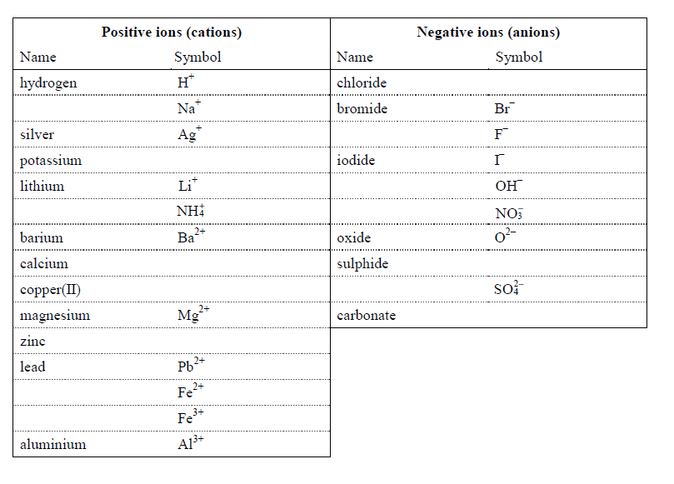

**Task 2**

From what you have learnt in task 1 now deduce the formula of the following ionic compounds

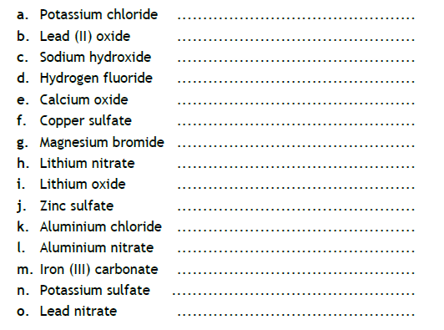

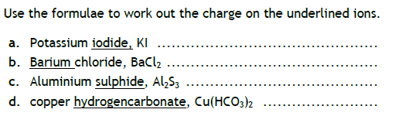

**Task 3**

Balance the following symbol equations…

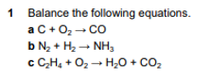

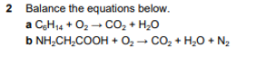

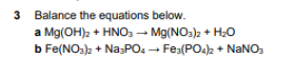

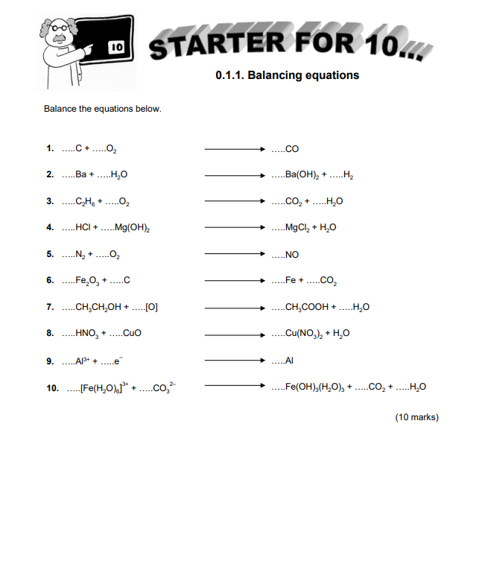

**Task 4**

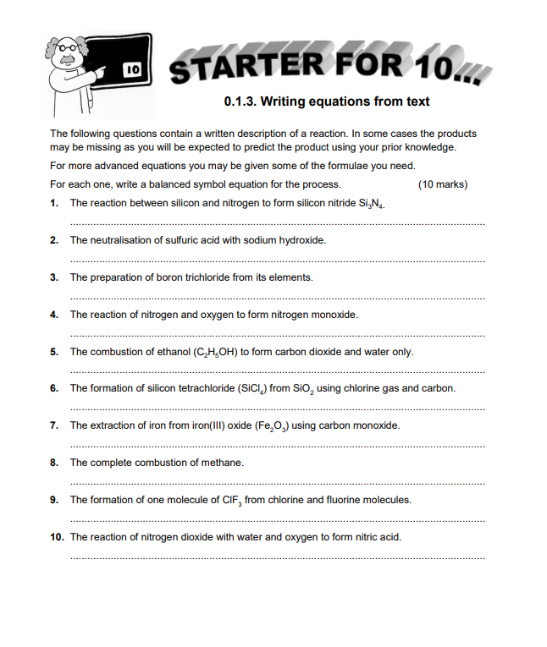

**Task 5**

Determine the units using the following equations

