

**Bridging the Gap from GCSE Physics and Preparing for A-level**

Bridging the Gap from GCSE Physics and Preparing for A-level

# The Transition from GCSE to A Level Physics

Welcome to A Level Physics!

We follow the Edexcel Physics (2015) specification and many of the details of this course can be found on the Edexcel Website below:

<http://qualifications.pearson.com/en/qualifications/edexcel-a-levels/physics-2015.html>

The aim of this guide is to provide you with some important information about the course and give you practice of some of the skills that you will need whilst studying physics at A Level. At the end is a list of suggestions of things you could do to ‘become a better physicist’.

How much of the booklet you do is up to you…but remember; the more you do, the easier you will find the transition to A Level Physics.

# **Physics is Challenging**

It is said time and time again, by people that should know better, that physics is a hard subject. But physics is like any other area of human endeavour. It is challenging because it is worth while.

Physics is challenging and it should be. If at any point you find the material too trivial, after checking you have the work correct, please ask for more demanding work. Education should be a mental gymnasium where you perspire, ache and then grow. Anyone will be able to succeed in a challenging field if they commit to working hard and are prepared to ask for advice and help.

This booklet will hopefully prepare in part for the challenges ahead. Over the summer it is strongly advised that you work through this booklet **and** revise the physics components from your GCSEs. A levels, in all subjects, are more challenging and rigorous than GCSEs so make sure you give ourself the best opportunity to succeed!

# **Measuring and Estimating**

Measuring techniques and being able to estimate quantities play a very important part in the A level Physics course. So here are a few tasks to do over the summer break. Be prepared to bring this work in and talk about it at the start of next term.

1. Using objects you can find in the kitchen, measure the density of water.
2. Explain how you did this and show all working.
3. Measure as accurately as you can the thickness of a yellow page from the YellowPages. Again explain how you did this and show all working.
4. Estimate the height of your house. Explain how you did this.
5. Work out how long your average foot step is using Google maps
6. Try to calculate the height of your house using trigonometry- do not measure it!

# **Practice Mathematics**

Many students worry about the mathematical content of physics A-level. It is true that the mathematical component of this course can be demanding yet there is no way to circumvent this. This challenge needs to be taken head on. "Practice makes perfect" should be the motto that is inscribed into your work ethic.

Below you will find five areas that need to be mastered for any student to succeed in A-level physics. Ideally, each section should be completed and understood by the time you start in September.

See you in September!

Mr Gillott

All Saints

# Estimation

In physics it can be very helpful to be able to make approximate estimates of values to within an order of magnitude. This means that the power of ten of your estimate is the same as the true value.

In many situations, physicists are not interested in specific answers, as circumstances can vary slightly and then the specific answer is incorrect. An order of magnitude answer will always be correct, unless you change the initial conditions by more than an order of magnitude. By estimating important quantities, like a typical mass for cars, we can get an approximate – order of magnitude – answer. The reason for doing so would be that it allows us to develop ideas as possible or impossible, and focus on developing the ideas along lines that will eventually be feasible when we get to developing a specific solution. This reduces time and money wasted by pursuing ideas that can never be realised.

It is also vital in quickly spotting when we have miscalculated the answer to a question. If we used a sophisticated equation to calculate the answer to the top speed of a particular car in particular conditions, and the answer came out as 300 000 metres per second, we should immediately know that the answer is incorrect, and re-check the calculation.

## TASKS

1. Give an order of magnitude estimate for the following quantities:
   1. the height of a giraffe
   2. the mass of an apple
   3. the reaction time of a human (d) the diameter of a planet

(e) the temperature in this room.

1. Answer the following estimation questions, showing all the steps and the assumptions and estimates you make.
   1. How many ping pong balls can fit into a Boeing 747?
   2. How many atoms are there in your body?
   3. How many heartbeats are there in a year for the entire world’s population?
   4. In your lifetime, how much will you earn in total?

# 1. Physical Quantities

Maths and Physics have an important but overlooked distinction by students. Numbers in Physics have meaning – they are the size of physical quantities which exist. To give numbers meaning we suffix them with units. There are two types of units:

|  |  |  |
| --- | --- | --- |
| **Basic quantity** | **Unit** | |
| **Name** | **Symbol** |
| Mass | kilogram | kg |
| Length | metre | m |
| Time | second | s |
| Current | ampere | A |
| Temperature | kelvin | K |
| Amount of substance | mole | mol |
| Luminous intensity | candela | cd |

**Base units** These are the seven fundamental quantities defined by the Système international d’U ités (SI units). Once defined, we can make measurements using the correct unit and make comparisons between values.

|  |  |  |
| --- | --- | --- |
| **Derived quantity** | **Unit** |  |
| **Name** | **Symbols** |
| Volume | cubic metre | m3 |
| Velocity | metre per second | ms-1 |
| Density | kilogram per cubic metre | kgm-3 |

**Derived units** These are obtained by multiplying or dividing base units. Some derived units are complicated and are given simpler names, such as the unit of power Watt (W) which in SI units would be m2kgs-3.

|  |  |  |  |
| --- | --- | --- | --- |
| **Quantity** | **Quantity symbol** | **Unit name** | **Unit symbols** |
| Length | L or l or h or d or s | metre | m |
| Wavelength |  | metre | m |
| Mass | m or M | kilogram | kg |
| Time | t | second | s |
| Temperature | T | kelvin | K |
| Charge | Q | coulomb | C |
| Momentum | p | kilogram metres per second | kg ms-1 |

**Notice that at A-Level we use the equivalent notation ms-1 rather than m/s.**

Do not become confused between the symbol we give to the quantity itself, and the symbol we give to the unit. For some examples, see the table on the right.

|  |  |  |  |
| --- | --- | --- | --- |
| **Prefix** | **Symbol** | **Name** | **Multiplier** |
| femto | f | quadrillionth | 10-15 |
| pico | p | trillionth | 10-12 |
| nano | n | billionth | 10-9 |
| micro | µ | millionth | 10-6 |
| milli | m | thousandth | 10-3 |
| centi | c | hundredth | 10-2 |
| kilo | k | thousand | 103 |
| mega | M | million | 106 |
| giga | G | billion | 109 |
| tera | T | trillion | 1012 |
| peta | P | quadrillion | 1015 |

O

Often the value of the quantity we are interested in is very big or small. To save space and simplify these numbers, we prefix the units with a set of symbols.

**Knowledge of standard form and how to input it into your calculator is essential.**

*For example:* 2.45 x 10-12 m = 245 pm

2.45 x 103 m = 2.45 km

We may need to convert units to make comparisons.

*For example:* Which is bigger, 0.167 GW or 1500 MW?

0.167 GW = 0.167 x109 W

= 167 x106 W

= 167 MW < 1500 MW

# Physical Quantities - Questions

1. The unit of energy is the joule. Find out what this unit is expressed in terms of the base SI units.

1. Convert these numbers into normal form:

|  |  |
| --- | --- |
| 1. 5.239 x 103 2. 4.543 x 104 3. 9.382 x 102 4. 6.665 x 10-6     3) Convert these quantities into standard form: | 1. 1.951 x 10-2 2. 1.905 x 105 3. 6.005 x 103 |
| 1. 65345 N 2. 765 s 3. 486856 W 4. 0.987 cm2 | 1. 0.000567 F 2. 0.0000605 C 3. 0.03000045 J |

1. Write down the solutions to these problems, giving your answer in standard form:
   1. (3.45 x 10-5 + 9.5 x 10-6) ÷ 0.0024
   2. 2.31 x 105 x 3.98 x 10-3 + 0.0013

1. Calculate the following:
   1. 20mm in metres
   2. 3.5kg in grams

## c) 5 000 i etres

1. 1m2 in cm2 (careful)
2. 38 cm2 in m2

6) Find the following:

1. 365 days in seconds, written in standard form
2. 3.0 x 104 g written in kg
3. 2.1 x 106 Ω written in MΩ
4. 5.9 x 10-7 m written in
5. Which is bigger? 1452 pF or 0.234 nF

# 2. Significant Figures

Number in Physics also show us how certain we are of a value. How sure are you that the width of this page is 210.30145 mm across? Using a ruler you could not be this precise. You would be more correct to state it as being 210 mm across, since a ruler can measure to the nearest millimetre.

To show the precision of a value we will quote it to the correct number of significant figures. But how can you tell which figures are significant?

## The Rules

1. All non-zero digits are significant.
2. In a number with a decimal point, all zeros to the right of the right-most non-zero digit are significant.
3. In a number without a decimal point, trailing zeros may or may not be significant, you can only tell from the context.

## Examples

|  |  |  |
| --- | --- | --- |
| Value | # of S.F. | Hints |
| 23 | 2 | There are two digits and both are non-zero, so are both significant |
| 123.654 | 6 | All digits are significant – this number has high precision |
| 123.000 | 6 | Trailing zeros after decimal are significant and claim the same high precision |
| 0.000654 | 3 | Leading zeros are only placeholders |
| 100.32 | 5 | Middle zeros are always significant |
| 5400 | 2, 3 or 4 | Are the zeros placeholders? You would have to check how the number was obtained |

When taking many measurements with the same piece of measuring apparatus, all your data should have the same number of significant figures.

For example, measuring the width of my thumb in three different places with a micrometer: 20.91 x 10-3 m 21.22 x 10-3 m 21.00 x 10-3m

Significant Figures in Calculations

We must also show that calculated values recognise the precision of the values we put into a formula. We do this by giving our answer to the same number of significant figures as the least precise piece of data we use.

*For example:* A man runs 110 m in 13 s. Calculate his average speed.

Speed = Distance / Time = 110 m / 13 s = 8.461538461538461538461538461538 m/s

*This is the same number of sig figs as the*  =8.5 m/s to 2 s.f. *time, which is less precise than the distance.*

# Significant Figures - Questions

1. Write the following lengths to the stated number of significant figures:
   1. 5.0319 m to 3 s.f.
   2. 500.00 m to 2 s.f.
   3. 0.9567892159 m to 2 s.f.
   4. 0.000568 m to 1 s.f.

1. How many significant figures are the following numbers quoted to?

* 1. 224.4343
  2. 0.000000000003244654
  3. 344012.34
  4. 456
  5. 4315.0002
  6. 200000 stars in a small galaxy
  7. 4.0

1. For the numbers above that are quoted to more than 3 s.f, convert the **↑** number to standard form and quote to 3 s.f.

1. Calculate the following and write your answer to the correct number of significant figures: a) 2.65 m x 3.015 m

* 1. 22.37 cm x 3.10 cm

* 1. 0.16 m x 0.02 m



d)

# 3. Using Equations

You are expected to be able to manipulate formulae correctly and confidently. You must practise rearranging and substituting equations until it becomes second nature. We shall be using quantity symbols, and not words, to make the process easier.

## Key points

* Whatever mathematical operation you apply to one side of an equation must be applied to the other
* Don’t try and tackle too many steps at once.

## Simple Formulae

The most straightforward formulae are of the form *a = b x c* (or more correctly *bc*).

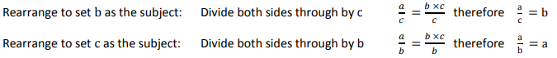

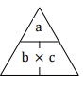

Alternatively you can use the formula triangle method. From the formula you know put the quantities into the triangle and then cover up the quantity you need to reveal the relationship between the other two quantities. This method only works for simple formulae, it doesn’t work for some of the more complex relationship’s, so you must learn to rearrange

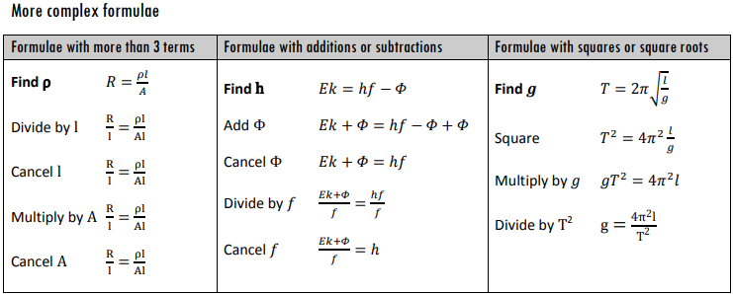

## Symbols on Quantities

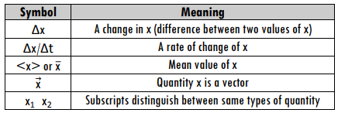

Sometimes the symbol for a quantity may be combined with some other identifying symbol to give more detail about that quantity. Here are some examples.

# Using Equations - Questions

Make t the subject in the following equations

* 1. V = u + at
  2. S = ½ at2
  3. Y = k(t-t0)
  4. F = mv/t
  5. 
  6. 

2) Solve each of the following equations to find the value of t:

1. 30 = 3t –3

1. 4(t +5) = 28
2. 
3. 
4. 
5. 

Straight Line Graphs Value along y-axis Value along x-axis

If a graph is a straight line, then there is a formula that will describe it. y = m x + c   
 Gradient Y-Intercept

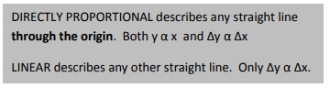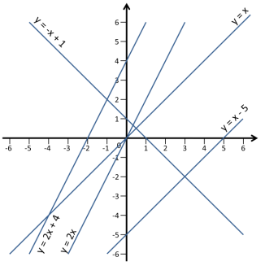

y = x A positive line through the origin

Gradient, m = 1   
y-intercept, c = 0

y = x – 5 Parallel to y = x but transposed by -5. Gradient, m = 1 Y

-intercept, c = -5

y = 2x A positive line through the origin Gradient, m = 2

y-intercept, c = 0

y = 2x + 4 Parallel to y = 2x ,transposed by 4. Gradient, m = 2

y-intercept, c = 4

y = -x + 1 A negative line, parallel to y = -x

Gradient, m = -1

y-intercept, c = 1

## Using Straight Line Graphs in Physics

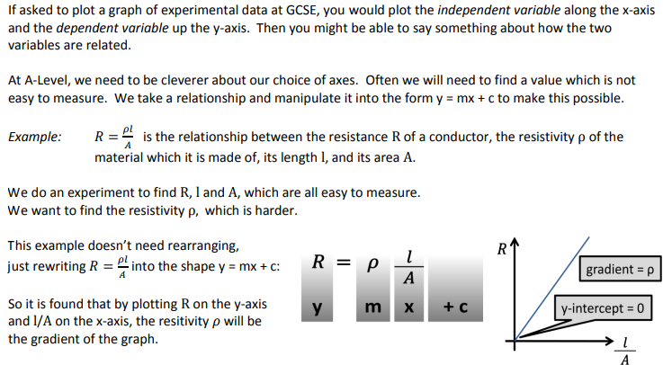

# Straight Line Graphs - Questions

1) For each of the following equations that represent straight line graphs, write down the gradient and the y intercept:

1. y = 5x + 6

1. y = -8x + 2

1. y = 7 - x

1. 2y = 8x - 3

1. y + 4x = 10

1. 3x = 5(1-y)

1. 5x - 3 = 8y

# 5. Trigonometry

When dealing with vector quantities or systems involving circles, it will be necessary to use simple trigonometric relationships.

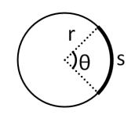

## Angles and Arcs

There are two measurements of angles used in Physics.

• **Degrees** There are 360o in a circle

### • Radians There are π radia s i a circle

**Whichever you use, make sure your calculator is in the correct mode!**

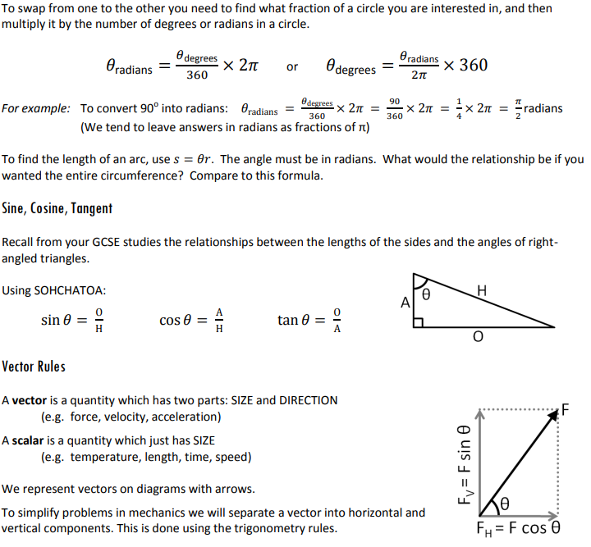

# Trigonometry - Questions

1. Calculate:
   1. The circumference of a circle of radius 0.450 m

* 1. the length of the arc of a circle of radius 0.450m for the following angles between the arc and the centre of the circle:
     1. 340o

* + 1. 170o

* + 1. 30o

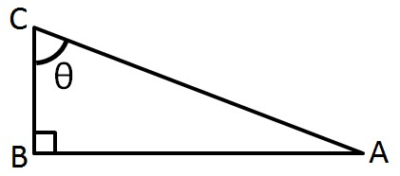

1. For the triangle ABC shown, calculate:
   1. Angle θ if AB = 0c a d BC = 0c

## b) Angle θ if AC = 0c a d AB = 5c

1. AB if θ = 36° and BC = 50 mm

1. BC if θ = 65° and AC = 15 km

3) Calculate the horizontal component A and the vertical component B of a 65 N force at 40o above the horizontal.

Bridging the Gap from GCSE Physics and Preparing for A-level

## **Mathematical Requirements**

A summary of the mathematical requirements appears below. Once you have mastered a concept you can place a tick next to that part of the mathematical content. This will serve as a visual check on what you need to work on and what to ask the teaching staff for advice on.

### 1. Arithmetic and numerical computation

1. recognise and use expressions in decimal and standard form
2. use ratios, fractions and percentages
3. use calculators to find and use power, exponential and logarithmic functions
4. use calculators to handle sin *x*, cos *x*, tan *x* when *x* is expressed in degrees or radians

### 2. Handling data

1. use appropriate number of significant figures
2. find arithmetic means
3. make order of magnitude calculations

### 3. Algebra

1. understand and use of symbols
2. change the subject of an equation
3. substitute numerical values into algebraic equations using appropriate units forphysical quantities
4. solve simple algebraic equations

### 4. Graphs

1. translate information between graphical, numerical and algebraic forms
2. plot two variables from experimental or other data
3. understand that *y* = *mx* + *c* represents a linear relationship
4. determine the slope and intercept of a linear graph

Bridging the Gap from GCSE Physics and Preparing for A-level

1. draw and use the slope of a tangent to a curve as a measure of rate of change
2. understand the possible physical significance of the area between a curve and the x axis and be able to calculate it or measure it by counting squares as appropriate
3. use logarithmic plots to test exponential and power law variations
4. sketch simple functions including *y* = *k*/*x*; *y* = *kx*2; *y* = *sinx*; *y* = *cosx*; *y* = *e*´*x*

### 5. Geometry and trigonometry

1. calculate areas of triangles, circumferences and areas of circles, surface areas and volumes of rectangular blocks, cylinders and spheres
2. use Pythagoras’ theorem, and the angle sum of a triangle
3. use sin, cos and tan in physical problems
4. understand the relationship between degrees and radians and translate from one to the other
5. use relationship for triangles: