A Level Geography (Physical)
Transition Task

Tectonic processes and hazards

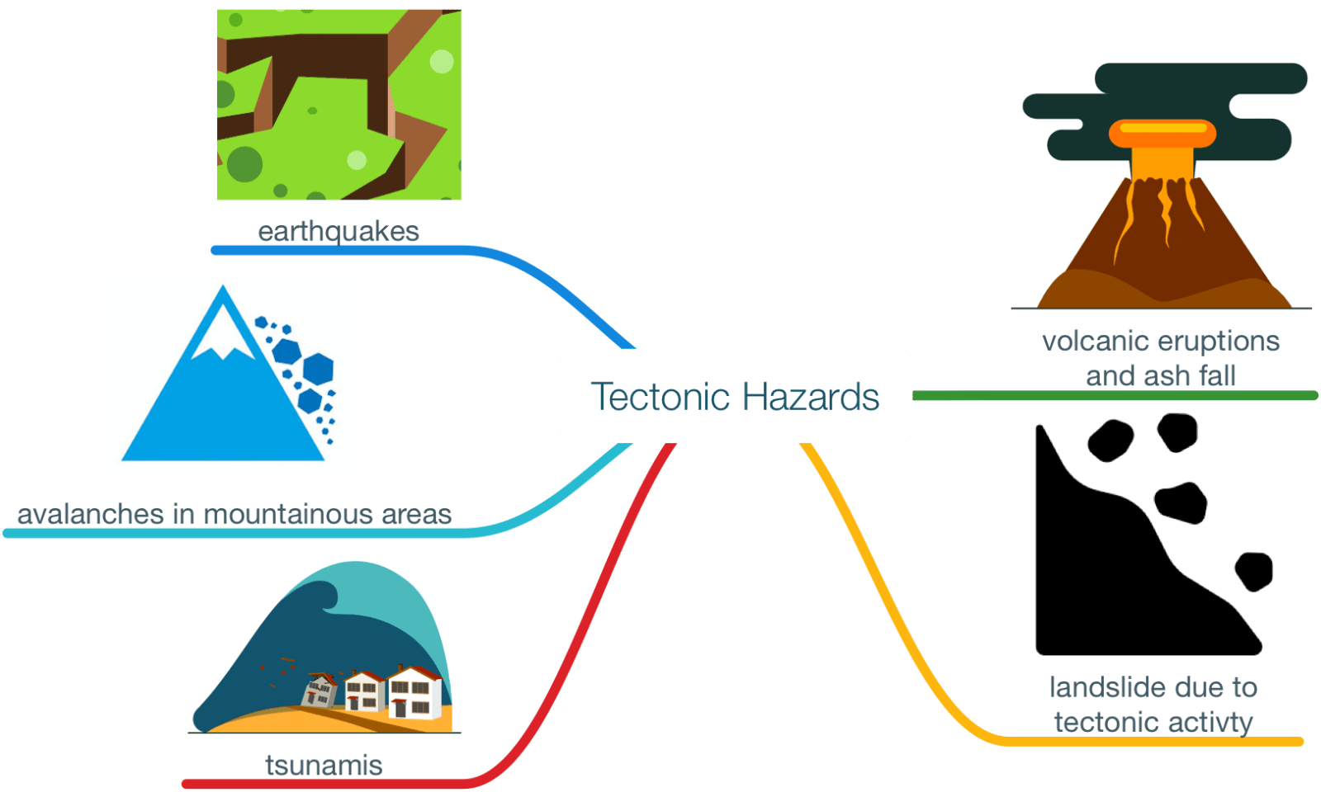

This GCSE level workbook will give you the basic knowledge you need as background for this topic in ‘A’ Level Geography

Name:

Video links to use:
https://timeforgeography.co.uk/videos_list/plate-tectonics/
https://www.youtube.com/watch?v=JGXi_9A__Vc&list=PLEbUo-BtusZtzyUPbgpLpa4mqkpPpcZHm
https://www.youtube.com/watch?v=oCPjgv2Pccc

KEY IDEAS
Revision Check:
Describe the distribution of tectonic activity?
Can you describe the contrasts between continental and oceanic plates?
Can you draw annotated diagrams and explain what happens at destructive, constructive and conservative plate margins?

A tectonic plate is a huge section of the Earth’s Crust. The plates move because of ‘convection currents’ of hot rising magma within the mantle. The radioactive decay that is happening in the core heats up the mantle which rises as it is less dense. The semi-molten rock spreads out and carries the plate above with it.
Figure 1 below shows the earth’s continental plates:
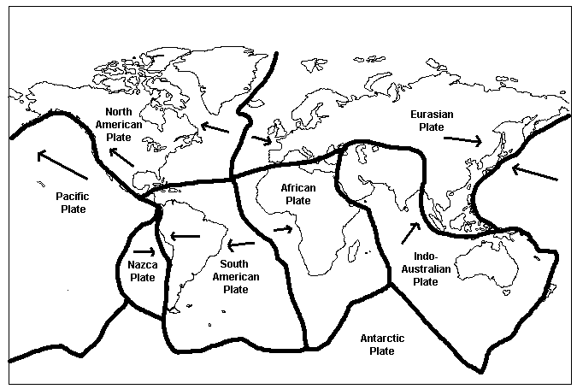
Plate Boundary examples:
Destructive:
Eurasian & Pacific
Nazca & South American
Constructive:
South American & African
Pacific & Nazca
Conservative:
North American & Pacific


In the exam you might have to describe the pattern or distribution of volcanoes, supervolcanoes or earthquakes.

There are 2 main types of plate: Continental e.g. Eurasian plate and Oceanic e.g. Pacific Plate.
In the exam you may have to compare and describe differences or compare the different types of crust.

Differences between the different types of crust:
Continental | WHEREAS | Oceanic
- Thicker and less dense than oceanic plates  - Mostly made of granite whereas oceanic crust is made of basalt  - They are situated underneath bodies of land (continents)  - Much older than oceanic plates – 1,500 million years old | WHEREAS | - Thinner and more dense (heavier) than continental crust  - Mostly made of basalt whereas continental crust is made of granite  - Flat and are situated under large bodies of water such as the Pacific Ocean  - Younger than continental plates – 200 million years old
If a Question asks you to compare or contrast always use the word whereas

Plate Boundaries:
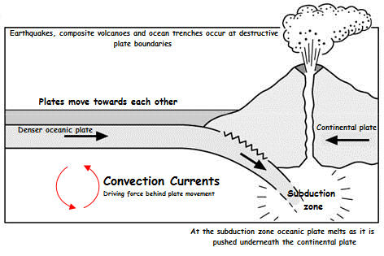
Destructive Plate Boundary – an example of this type of plate boundary is the Nazca and South American plates.
- Two plates move towards each other.

- One is made from oceanic crust and one of continental crust.

- The denser and thinner Oceanic plate is pushed downwards and is forced into the subduction zone where there is great amounts of heat + Pressure.

For example, Nazca plate is forced to sink below the South American plate.

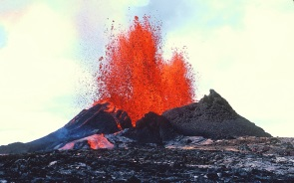  Why do composite volcanoes occur at destructive plate boundaries? | 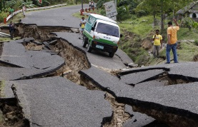  Why do earthquakes occur at destructive plate boundaries?
The molten rock may rise to form composite volcanoes. This rises and the pressure is released in an explosive eruption often along a fault – giving a steep sided volcano of lava and ash. | This exerts great pressure on the crust and the release of the pressure that has built up over time causes the plates to shift and results in an earthquake.

Plate Boundaries:

Constructive Plate Boundary – an example of this type of plate boundary is the North American plate and Eurasian plate
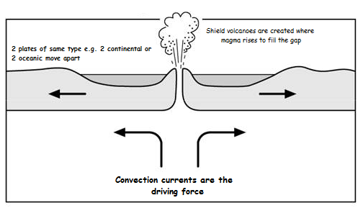
- This is when 2 of the same types of plates (e.g. 2 oceanic or 2 continental) are moving apart from each other.
- This is the result of convection currents.
- As the plates move apart, a ‘gap’ is created between the plates.
- This type of movement mostly happens under the oceans. As plates pull apart the gap is filled by magma rising up from the mantle below.
- Magma cools and forms new crust. This is most common under oceans. As this occurs again and again, layers of lava solidify and build up to create volcanoes. This often happens under the oceans.
- The rising magma creates shield volcanoes, which if they become high enough, form volcanic islands such as Iceland and the Hawaiian Islands.
- The energy from the movement of the plates may also be released as an earthquake.

Conservative Plate Boundary – an example of this type of plate boundary is the San Andreas Fault
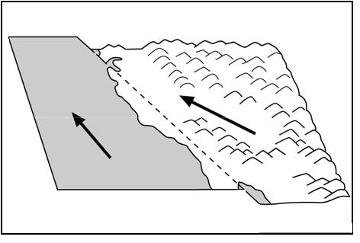
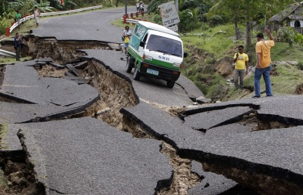
Any two plates sliding past each other -They may be moving in different directions or the same direction but at different rates. Pressure builds up along the fault until one plate jerks past the other causing an earthquake. The movement is not smooth and friction builds up resulting in a ‘stick- slip’ process. The movement also causes the land to become crumpled and ridged.
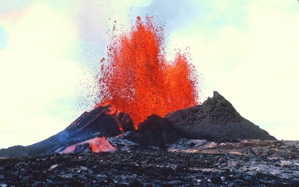

Convection currents are the driving force behind plate movement
NO VOLCANOES

TASK: In the space below, practise drawing out the different plate boundaries.

Don’t forget to…
- Show the direction the plates are moving with arrows
- Label on convection currents
- Label on the plate type – e.g. oceanic or continental

KEY IDEAS
Revision Check:
Can you describe and explain the formation of fold mountains?
Can you describe and explain the formation of ocean trenches?
Can you describe the characteristics of different volcanoes and explain the formation of composite and shield volcanoes?

Fold Mountains
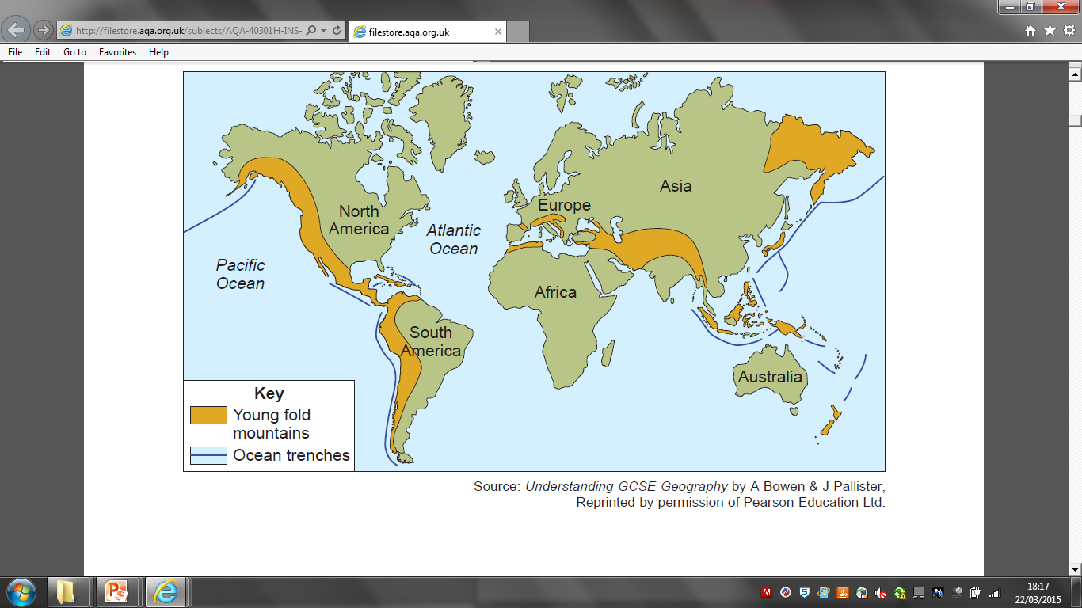
What is a fold mountain?
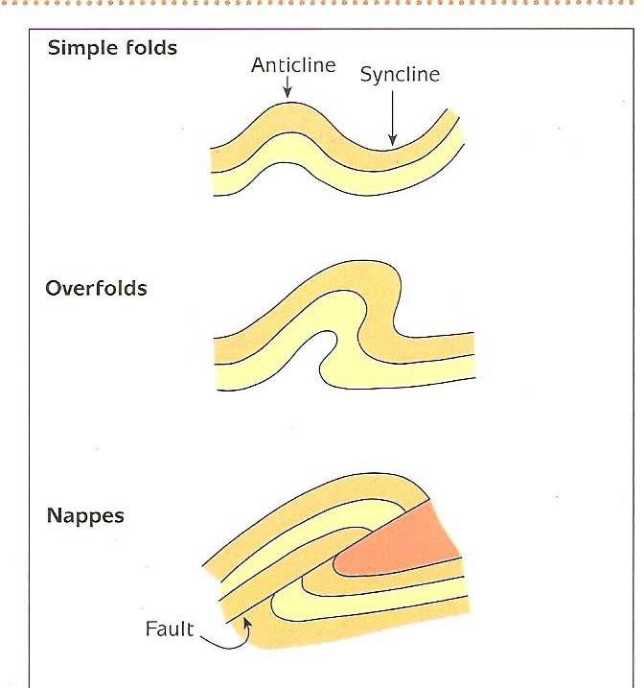
Fold mountains are large ranges of mountains where different rock layers have crumpled into anticlines and synclines as they have pushed together. They are found on destructive plate boundaries all over the world. Fold mountains are made of the folds were simple upfolds (anticlines) and downfolds (synclines).

Characteristics of Fold Mountain areas:
- Fold Mountain areas have very high mountains with very steep slopes. (e.g. The Matterhorn)
- At the highest/Coldest point, there is usually lots of snow.
- Many Glaciers are formed by erosion.
- Sometimes, lakes are found in the valleys between the mountains. (e.g. Lake Geneva)

What is an ocean trench?
Ocean Trenches are deep water areas that run along coastlines which have a destructive plate margin. They are created by subduction, and mark the point where the oceanic crust is being pushed under the continental crust.
Figure – the world distribution of young fold mountains
How are fold mountains and ocean trenches formed?
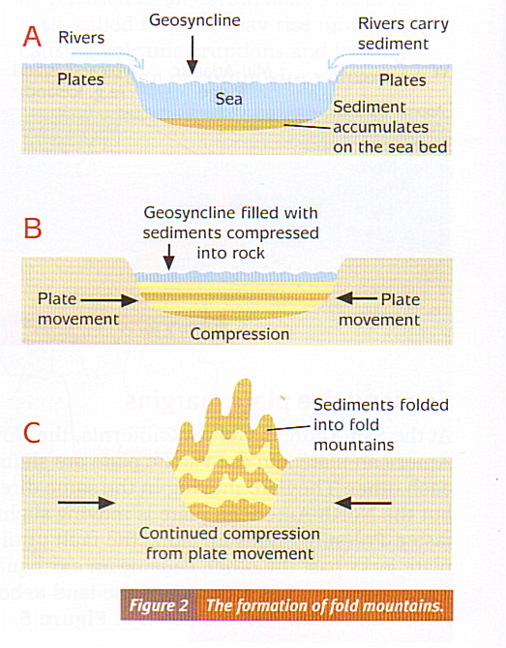
Rivers erode material from land surface and transport it to sea. Sediment is deposited on ocean floor, layers build up over time forming sedimentary rock due to compression. Plates move together, at destructive boundaries.

If the 2 plates moving together are made of the same type of crust e.g. continental crust then neither of the plates will be subducted instead the rocks crumple as a result, forming fold mountains, with anticlines and synclines. This continues even when the ocean has been removed for example, Himalayas.

Fold mountains can also form at subduction zones where the continental crust crumples as it meets the oceanic crust. Here also, the oceanic crust gets pushed below the continental crust. At this point, the sea is very deep and it is here that there are ocean trenches. (destructive plate boundary)

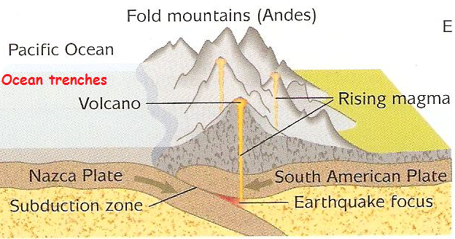

TASK: In the space below, practise drawing a diagram to explain the formation of fold mountains and ocean trenches.

Don’t forget to…
- Show the direction the plates are moving with arrows
- Label on convection currents
- Label on the plate type – e.g. oceanic or continental

KEY IDEAS
Revision Check:
Can you describe the characteristics of different volcanoes and explain the formation of composite and shield volcanoes?
Can you describe how volcanoes are monitored and predicted?
Can you explain the advantages and disadvantages of living near a volcano?
Volcanoes
A volcano is a cone shaped mountain created by lava from repeated eruptions. They are found along constructive and destructive plate margins.
Types of Volcano: Volcanoes are divided into two main types depending upon the material throw out in an eruption.
Composite Volcano (cone volcano) for example, Mt Vesuvius / Mt Etna / Mt St Helens
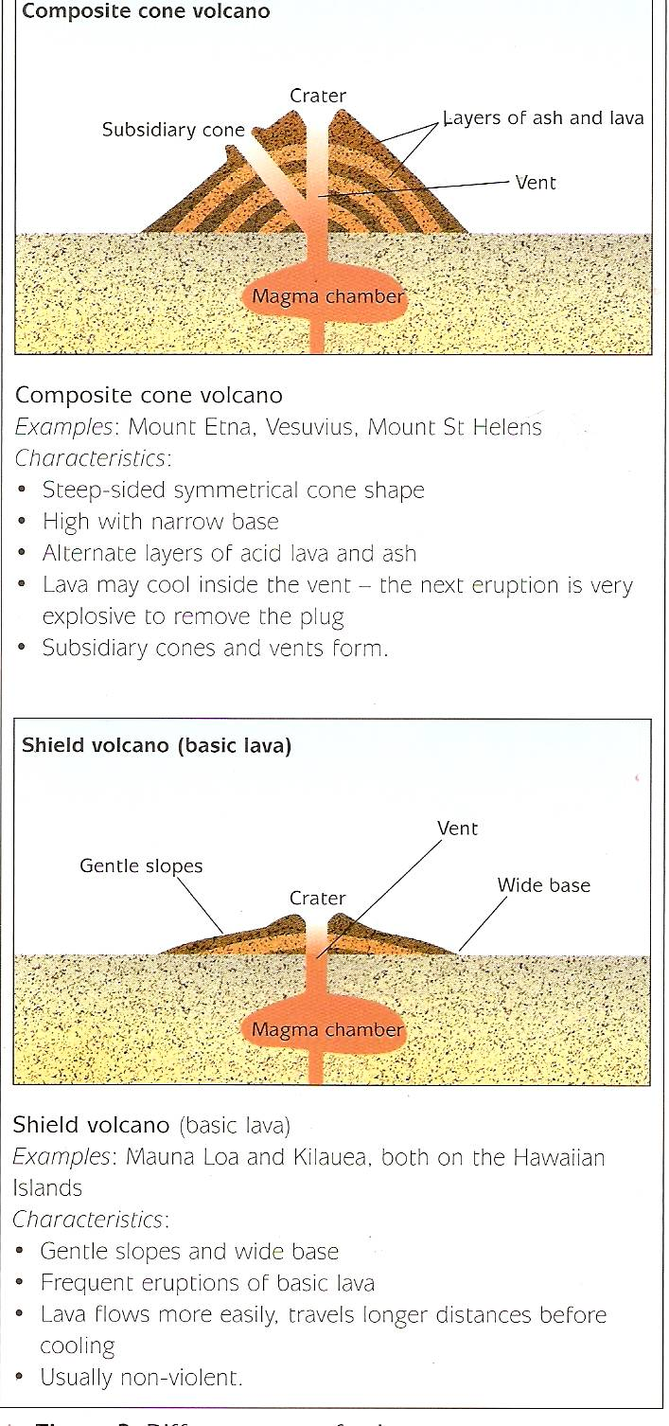
Characteristics:
- They have a steep-sided symmetrical cone shape.
- High with narrow base.
- Alternate layers of acid lava and ash.
- The lava is usually very thick and slow flowing.
- Eruptions are usually very explosive because gas builds up under pressure and then is released very suddenly with great force.
- Subsidiary cones and vents form
- Less Frequent and Violent eruptions e.g. Mount Vesuvius (79 AD)
Shield Volcano for example, Mt Loa, Hawaii
Characteristics:
- They have a gentle slopes and a broad base
- Flat / Rounded top / Low lying
- Frequent eruptions of basic lava (non explosive)
- Made of runny lava / basaltic lava
- Very little ash
- Lava flows more easily, travels longer distances before cooling. The runny lava spreads quickly over a wide area, forming a low, flat volcano
- Usually frequent non-violent eruptions
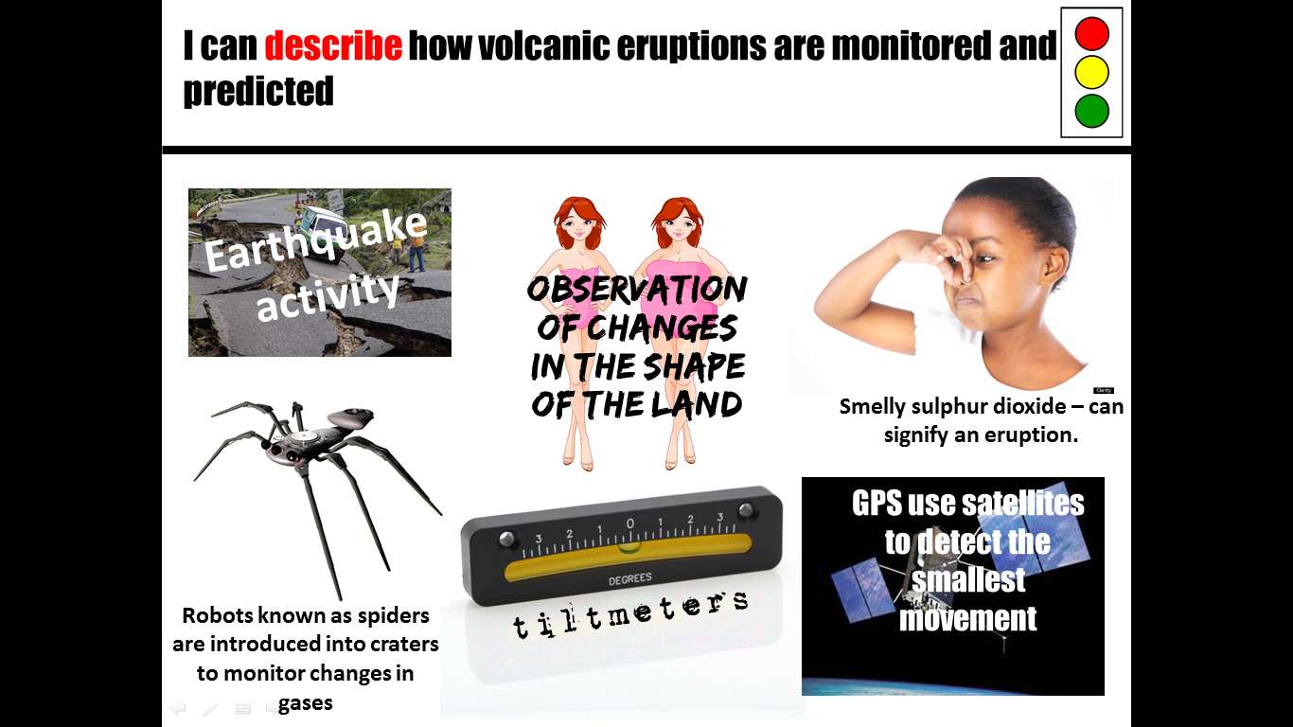
How are volcanoes monitored and predicted?
Millions of people live in areas vulnerable to volcanic eruptions. With so many lives at risk it is important that scientists try and predict volcanoes to try and evacuate as many people as possible from the area. Scientists monitor Volcanoes by checking for signs:
- Monitoring Seismic activity using Seismometers- Sometimes big eruptions can start with small tremors.
- Escaping gases can be monitored using ultra violet detectors.
- Scientists look out for changes in the shape of the volcano (bulges in the mountain where magma builds up beneath it).
- Earthquake activity is monitored as this can be a sign or a trigger of a volcanic eruption. Observation of changes in the shape of the land and more accurately the use of tiltmeters to identify and record such changes.
- GPS use satellites to detect the smallest movement – of a mm and robots known as spiders are introduced into craters to monitor changes in gases – especially sulphur dioxide – which can signify an eruption. All of these allow people to prepare and to evacuate if necessary.
KEY IDEAS
Revision Check:
Can you describe the cause of earthquakes?
Can you define the features of an earthquake including epicentre, focus and shockwaves?
Can you describe how earthquakes are measured using the Richter and Mercalli scales?

Earthquakes

Earthquakes are vibrations in the Earth’s crust. They are sudden and because they happen without warning, often lethal – 1.5 million people have died since 1900 as a result of earthquakes. The magnitude of an earthquake is measured using a seismograph and then given a value of between 1 and 10 on the Richter scale. The scale is logarithmic: an earthquake measuring 6 is ten times more powerful than an earthquake measuring 5.

Why do earthquakes happen?
Most earthquakes are caused by movement along a fault. They CAN occur ANYWHERE but they are most serious along plate boundaries. Over 90% happen where plates are colliding at destructive plate boundaries and they are often more violent.

Key terms associated with earthquakes:
Focus- the intrusive point where the earthquake starts.
Epicentre- the extrusive point (on surface) where the earthquake starts.
Shockwaves- Vibrations emitted from Tectonic collisions.

The effects of earthquakes:
The destructive effects of earthquakes can be classified into primary and secondary effects.
Primary Effects: are the immediate damage caused by the quake, such as collapsing buildings, roads and bridges, which kill many people. Those lucky enough to survive can suffer badly from shock and panic.

Secondary Effects: are the after-effects of the earthquake such as; fires, tsunamis, landslides and disease.

Fires; are caused by burst gas pipes/electric cables. These fires are hard to extinguish as water pipes might be broken and roads are often blocked preventing emergency services getting through. Fires spread very quickly in cities, especially poor quality housing areas which are usually made of wood. Fires killed about 25% of the victims in Tokyo in 1923 after the Kanto earthquake.

Tsunamis – (huge waves) an earthquake on the sea floor can cause huge waves. The Boxing Day earthquake in 2004 caused a series of enormous waves to hit numerous countries in the Indian Ocean. This disaster killed over 225,000 people (both locals and tourists) as well as wiping out houses, roads, bridges and schools.

Landslides – earthquakes often cause landslides, especially in steep river valleys and areas of sand or clay. In 1970 a huge landslide in Peru caused a landslide high in the Andes mountains which killed 20, 000 people.

Disease and famine – fresh water supplies are often cut off due to burst water pipes. Typhoid and cholera can spread easily, especially in large cities cut off from medical supplies by damaged communications.

Measuring earthquakes
Scientists use two universal scales to measure Tectonic Movement (earthquakes):
1. The Richter Magnitude Scale
Richter Scale uses information collected by seismometers that record the strength of shock waves and amount of movement. A seismogram is produced showing a ‘line graph’ of the waves. This is used to assign a number on the Richter Scale between 0/1 and notionally 10 (but there is no
upper limit). The scale is logarithmic so that an increase of 1 represents
a 10 fold increase and of 2 a hundred times etc.

2. The Mercalli Scale
The Mercalli scale is a scale which is measured by asking eyewitnesses for observations of what has happened. This is less commonly used as different people have different criteria when it comes to assessing damage after a disaster.

The two scales have different applications and measurement techniques. The Mercalli scale is linear and the Richter scale is logarithmic. i.e. a magnitude 5 earthquake is ten times as intense as a magnitude 4 earthquake.

- Explain how earthquakes can occur at destructive / constructive / conservative plate boundaries. (You may use a diagram to support your answer) (4 marks)

- What is the difference between the focus and epicentre of an earthquake? (2 marks)

- Describe a method, other than the Richter Scale, of measuring earthquakes. (3 marks)

- Compare the Richter scale with the Mercalli scale. (4 marks)

- Outline how to Richter scale is used to measure earthquakes. (3 marks)

CASE STUDY – KOBE EARTHQUAKE, JAPAN - HIC COUNTRY (1995)
Revision Check:
Can you explain the specific causes of an earthquake in a richer part of the world?
Can you describe the primary and secondary effects?
Can you describe the immediate and long term responses – the need to predict, protect and prepare?
When: 17 Jan 1995 at 5.46am – it lasted 20 seconds!
Magnitude: 7.2 Richter scale.
Why: Along the east coast of Japan, the Pacific plate is subducted under the Eurasian plate (destructive plate margin) at a rate of 10cm per year. The stress created by this movement was suddenly released, sending shockwaves along the fault line. The epicentre was on the Awaji Island in Osaka Bay. Focus was 14km deep. One of the reasons why the effects of the earthquake was severe was because there was a very shallow focus of only 16km and the epicentre was very close to the settlement.

Social effects:
- 5,500 people were killed.
- 30,000 people injured.
- 300,000 people left homeless.
- Loss of schooling (10% schools destroyed).
Structural damage:
- Important buildings (e.g. hospitals) collapsed.
- 80% of schools, museums, sports facilities damaged.
- 100,000 houses collapsed.
- Buildings built before 1960s were not designed to withstand earthquakes.
- Elevated structures like the Hanshin Expressway or Shinkansen (‘bullet train’) track collapsed.
- 10% of the city’s infrastructure was lost (roads, railways, electricity, gas and sewerage systems). Electricity supply was cut off leaving 2 million homes without power.
Economic effects:
- 80% of shoe factories destroyed (major export).
- 25% of phone lines damaged.
- Power was cut for 6 days.
- The earthquake and aftershocks caused landslides, and areas of soil liquefied in the sands along the coast and in areas of reclaimed land. This devastated 90% of the port of Kobe. Trade in and out of the port was therefore affected.
- £80 billion – estimated cost (in loss of earnings and repairing damage).

What made it worse?
- Unexpected – area was thought to be safe.
- Rain, strong winds and lightening increased the risk of landslides.
- Fires spread due to ruptured gas supplies.
- Water supply cut off. Over 1 million homes were without water for 10 days.
- Outbreaks of disease due to damp unhygienic shelters.
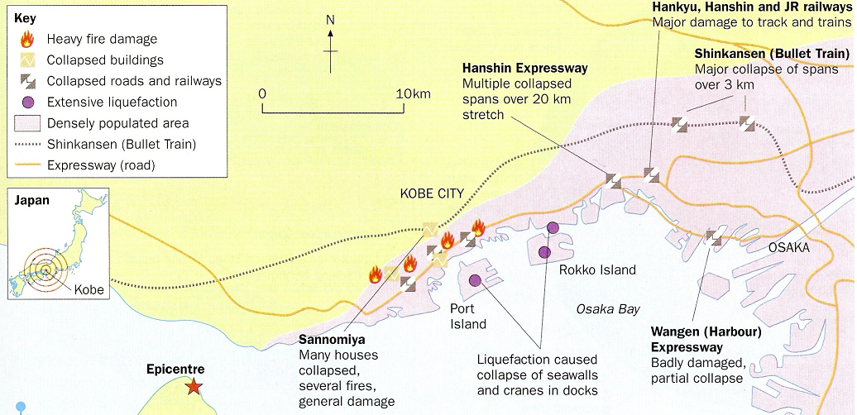
- Urban areas built on coastal land reclaimed from the sea. Shock waves last longer, so more damage is done. Also, liquefaction occurs – this is a process where water in the ground is shaken to the surface and the ground acts like quick sand – buildings topple and sink into the ground.
- Very high population density.
- More than 150 fires occurred in Kobe. Fire-fighters could not tackle them because streets were blocked by collapsed buildings, debris and traffic.
- Over 2000 fractures in the water system were blamed for the initial delays in restoring supplies.
Although a richer country, the effects of this disaster were great because of the high population density.

Primary effects – damage caused by the shaking of the ground (e.g. 200,000 collapsing buildings, roads, bridges). The ground had moved 18cm horizontally and 12 cm vertically, 130km of the bullet train route was destroyed.

Secondary effects – Not directly caused by the shaking of the ground (e.g. fires and disease). Electricity, gas and water supplies were disrupted, roads were gridlocked, delaying ambulances and fire services. Fires caused by broken gas pipes destroyed a further 7,500 homes. Industries such as Panasonic were forced to close.

TASK: In the table below explain as fully as you can the sequence of events that led to the development of these two secondary effects. Use the ideas beneath to help you structure your answers.

Fires | Disease
Gas pipes destroyed.  Electric cables.  Broken water mains prevent fires from being extinguished.  Fires spread quickly through the poor quality wooden buildings. | Fresh water supplies often cut off due to burst water pipes.  Typhoid and cholera can spread easily, especially in large cities cut off from medical supplies by damaged communications.
Responses
Within the first week of the earthquake... | Two weeks later... | In the longer term...
- Emergency shelter provided for 316,000 people in public buildings. People were still at risk from unstable buildings and fires.  - Meals and bottled water were flown in.  - Japanese army coordinated the rescue.  - Bulldozers began to clear fallen buildings as well as knock down unsafe buildings.  - The electricity supply was restored and telephone lines began to work again.  - Some shops and schools reopened. | - More railways and highways were reopened.  - Overcrowding in makeshift shelters became a health hazard and the cold weather led to a flu epidemic.  - Many people needed help to cope with the stress and shock of the earthquake. | - By July, Kobe’s infrastructure (Electricity, gas, telephones were back in place.)  - The city was re-zoned with more open space and wider roads.  - Kobe estimated that it would take five years to build 80,000 houses and flats for those made homeless. But after just one year there were only 1,000 victims still living in tents, and the town won an international award for the speed at which it got back to business.  - Still some homeless people.  - Mid 1997 – most manufacturing restored. Sales had risen to 80% of pre-earthquake levels.  - Buildings are designed to minimise damage. The Japanese government built homes according to strict building regulations to make sure houses were safe. These regulations were also applied to buildings. Buildings had to be ‘life safe’. Buildings were built with flexible frames and fire resistant materials and they were only built on solid ground.  - The Japanese Government was heavily criticised for its response to the earthquake. Relief efforts were condemned for being slow, uncoordinated and badly equipped.
- For an earthquake that you have studied in a richer country, describe and explain some of the primary and secondary effects.

- For an earthquake that you have studied, explain some of the factors that made the disaster worse.

HAITI EARTHQUAKE – HAITI, CARIBBEAN ISLAND – POORER COUNTRY (2010)
Revision Check:
Can you explain the specific causes of an earthquake in a poorer part of the world?
Can you describe the primary and secondary effects?
Can you describe the immediate and long term responses – the need to predict, protect and prepare?
When: 4.53pm, 12th January 2010 (Worst earthquake in 200 years)
Magnitude: 7.0 on the Richter Scale
Why: Haiti lies close to the boundaries of two tectonic plates. The Caribbean and the North American plates. The earthquake was caused by the North American Plate sliding past the Caribbean Plate at a conservative plate margin. Both plates move in the same direction, but one moves faster than the other. The pressure that was built up because of the friction between the 2 plates was eventually released causing a magnitude 7 earthquake on the Richter Scale with an epicentre 16 miles West of Port-au-Prince and a shallow focus of 5 miles. The earthquake had a shallow focus of 13 km below the earth’s surface. Seismologists had warned of a huge earthquake as this fault had been “locked” for 250 years. They predicted that there would be a huge release of stress that had been building up for centuries.
Primary effects
- 280,000 buildings collapsed (90% of Haiti’s buildings – including the President’s Palace and 60% of government buildings)
- More than 50 hospitals were destroyed
- 316,000 deaths
- 1 million people were made homeless
- Overall 3 million people were affected by the earthquake
- 16,500 schools were damaged or completely destroyed
- 3 main universities were severely damaged
- Severe famine cause by food shortages
- Transport and communication links were badly damaged
- The main prison was damaged – 4,000 inmates escaped
Secondary effects
- Roads were blocked for 10 days after the quake – this made it difficult getting aid into the area
- The large number of deaths meant that hospitals and morgues became full and bodies had to be piled on the streets and in most cases buried in mass graves
- The large number of bodies meant that diseases, especially cholera became a serious problem
- The international airport was made unusable due to control tower damage
- 1 in 5 people lost their job because so many buildings were destroyed. Haiti’s largest industry clothing was one of the worst affected
- People were squashed into shanty towns or onto the streets because their homes had been destroyed leading to poor sanitation and health. Looting also became a real problem
- 2 months after the quake the rainy season began which caused the further spread of disease and mudslides
- The public telephone system was knocked out, with no sign for mobile phones and internet
Responses: Haiti is a poorer country before the earthquake 80% of people lived on $2 or less a day and only 46% had access to clean water
Within the first week of the earthquake... | Two weeks later... | In the longer term...
- By 16th January, US helicopters were beginning to distribute aid to remote places.  - In the North of Haiti, mass graves were built and tens of thousands of bodies were brought by dumper trucks.  - 810,000 people placed in aid camps  - Healthcare supplies provided to limit disease  - Many countries responded to appeals for aid, pledging funds and dispatching rescue and medical teams, engineers and support personnel.  - There was much confusion over who was in charge, air traffic congestion, and problems with prioritization of flights further complicated early relief work. | - 4.3 million people provided with food rations in the weeks following the earthquake. | - The EU gave $330 million and the World Bank waived the countries debt repayments for 5 years.  - The Senegalese offered land in Senegal to any Haitians who wanted it.  - Between 23 major charities, $1.1 billion had been collected for Haiti for relief efforts, but only two percent of the money had been released.  - One year after the earthquake 1 million people still remained displaced.  - 98% rubble on the roads still hadn’t been cleared a year later!!  - Temporary schools created and new teacher trainee programme created  - Water and sanitation eventually supplied to 1.7 million
- For an earthquake that you have studied, explain some of the factors that made the disaster worse.

- Using examples of earthquakes, explain why some cause more deaths than others.

COMPARING EARTHQUAKES IN RICHER AND POORER COUNTRIES
Revision Check:
Can you COMPARE the effects of an earthquake in a richer and poorer part of the world?
Can you COMPARE the responses of an earthquake in a richer and poorer part of the world?

The effects of earthquakes and responses to them differ due to contrasts in levels of wealth.
Use the previous pages and your own knowledge to complete the table below:
COMPARING EFFECTS:

FACTORS | KOBE EARTHQUAKE, 1995 | HAITI EARTHQUAKE, 2010
SOCIAL EFFECTS

ECONOMIC EFFECTS

ENVIRONMENTAL EFFECTS

POLITICAL EFFECTS

Use the previous pages and your own knowledge to complete the diagram below:

COMPARING RESPONSES:

Kobe Earthquake, 1995
Haiti Earthquake, 2010

How were the responses similar?

How were their responses different?

Immediate Responses?

2 weeks later?

Long Term Responses?

MONTSERRAT VOLCANIC ERUPTION - Caribbean Island (1997)
Revision Check:
Can you explain the specific causes of a named volcanic eruption?
Can you describe the primary and secondary effects of a named volcanic eruption?
Can you describe the positive and negative impacts of the eruption?
Can you describe the immediate and long term responses?
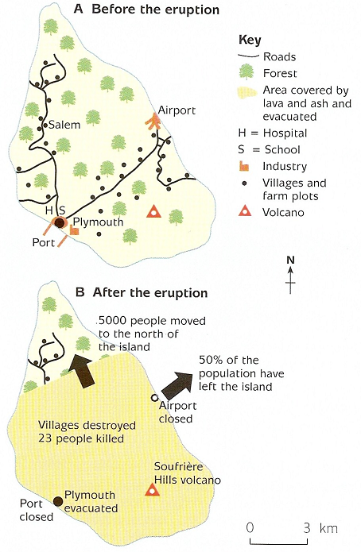
Where:
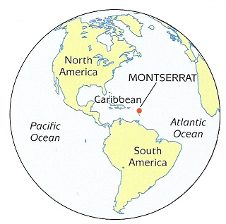
When: Erupted on 25th June 1997 (small eruptions started in 1995). 4.5 million metres cubed of rocks and gases released.
Causes: Montserrat is above a destructive late margin, where the Atlantic plate is being forced under the Caribbean plate. Magma rose up through weak points under the Soufiere hills forming an underground pool of magma. The rock above the pool collapsed, opening a vent and causing the eruption.
Background:
- Many of the residents of Montserrat are quite poor, living in small villages and practising subsistence farming.
- Before the eruption the population was 12,000 (50% of whom lived in the capital city, Plymouth).
- The south of the island was the most developed, with the main towns, communications and services. In the north there were few roads and settlements.
Primary effects of the eruption:
- Two thirds of the island covered in ash
- 23 people died in 1997 / 7 people were injured
- The capital, Plymouth became a ghost town as it was buried under 12m of ash
- Floods as valleys blocked with ash
- Airport and port closed
- Farmland destroyed
- Forest fires caused by pyroclastic flows
- Schools and hospitals destroyed
- 20 villages were destroyed by pyroclastic flows
Secondary effects of the Eruption:
- As most of the southern area was destroyed any remaining inhabitants have had to endure harsh living conditions in the North
- Fires destroyed many buildings including local government offices and the town’s central petrol station which led to further fires
- Transport remains a problem for people travelling to the island
- The country’s tourist industry stopped with the closure of the airport, and other industries are suffering with restricted port activities. The tourist industry is still suffering with few visitors except for cruise ships looking at the volcano
- Volcanic ash from the eruption has improved the soil fertility. Volcanic soils are some of the most fertile in the world due to the weathering of volcanic products such as ash lava and rock, which release valuable nutrients and minerals which enrich the soil as well as improving soil characteristics such as moisture retention. In tropical areas in particular, climate conditions mean that the weathering of lava etc. is fairly quick resulting in the growth of lush vegetation due to the rapid soil formation. As volcanic areas are therefore ideal for growing crops
- Over half the population left the island and have not returned
- Despite tourism being affected due to the spectacular scenery associated with volcanic landscapes and unique features such as lava flows and geyers, volcanoes, particularly those having experienced recent eruptive activity are particularly popular with tourists
- Valuable minerals such as copper, gold, silver, lead, zinc and even diamonds are all associated with volcanic regions as they are associated with the rising magma which may cool and harden beneath the volcano. As hot water circulate within the cooled magma, the metals are taken by the water and re-deposited in greater concentrations. Thus volcanic areas are excellent areas for mining creating economic activities through job opportunities and the value of the mined minerals

TASK: Colour the immediate responses in one colour and the long term responses in a different colour.

Scientists monitored the volcano and set up warning systems via radio, loudhailer and sirens.
The UK government sent £17 million of emergency aid, including temporary buildings and water purification systems.
People moved back. By 2005 the population was over 8,000.
The UK government funded a 3 year redevelopment programme for houses, schools, medical services, infrastructure, and agriculture.
Many of the evacuees are forced to live in makeshift shelters with inadequate sanitation; there were few schools and no proper hospital, and living conditions are very poor.
Charities like the Red Cross set up temporary schools.
5,000 people left the island (settling on nearby islands or moving to Britain).
Charities sent emergency food for farm animals.
The country’s tourist industry stopped with the closure of the airport, and other industries suffered with restricted port activities.
The USA sent troops for the evacuation.
Aid totalling $41 million has been offered to redevelop the north of the island and £10.5 million to relocate refugees.
5,000 people moved to the north of the island that was considered safe.
A risk map was created and an exclusion zone is in place. The south of the island is off limits while the volcano is still active.
The UK has provided £41 million to develop the north of the island – new docks, an airport and houses have been built in the north.
The Montserrat Volcano Observatory has been set up to try and predict future eruptions.

The positive impacts of a volcanic eruption.

Despite the well-known hazards associated with volcanic eruptions, it is estimated that 360 million people still live in volcanically active areas. So why do people still live near volcanoes? What are the positive impacts of volcanic eruptions?
Reason: Fertile Soils are left behind after eruptions
Explanation: Volcanic soils are some of the most fertile in the world due to the weathering of volcanic products such as ash lava and rock, which release valuable nutrients and minerals which enrich the soil as well as improving soil characteristics such as moisture retention. In tropical areas in particular, for example Monserrat, climate conditions mean that the weathering of lava etc. is fairly quick resulting in the growth of lush vegetation due to the rapid soil formation. As volcanic areas are therefore ideal for growing crops.
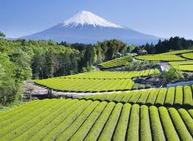
Example: In Java (Indonesia) some of the best rice growing areas are in the shadow of volcanoes such as Mt Merapi which attract large numbers due to the rich farming opportunities (1 million live within 20 miles of Merapi). Likewise, in Italy large numbers live on the slopes of Vesuvius and Etna (one in five Sicilians are belived to live on the slopes of Etna) due to the fertile soils which provide rich opportunities for growing products such as Olives and fruit.
Reason: Geothermal Energy
Explanation: Heat from magma sources close to the surface in volcanic areas can be used as a source of Geothermal energy which can be harnessed to produce electricity. In these instances, superheated steam, created by the heating of water in permeable rocks in magma can be used to drive turbines. This use of energy is renewable and sustainable, it has the added advantage of being pollution free.
Example: Over 20 countries around the world generate geothermal power, including the US, Italy, New Zealand and Iceland. In fact 17% of Iceland's electricity is created in this way.
In farming areas around Reykjavik (Iceland), geothermal energy is also used to heat greenhouses enabling the growing of fruit, vegetables and flowers.
Reason: Tourism
Explanation: Due to the spectacular scenery associated with volcanic landscapes and unique features such as lava flows and geyers, volcanoes, particularly those having experienced recent eruptive activity are particularly popular with tourists. This is a huge economic benefit due to the resulting multiplier effect. Tourism attracts curstom for businesses such as hotel, cafes etc. creating jobs and improving the local economy.
Example: Yellowstone National Park in the USA with the famous Old Faithful geyser receives around 3 million visitors a year. Iceland is famous for its volcanic landscpae and its hot springs and geysers have attracted many tourists. The Blue Lagoon, near Reykjavik is a spa popular with tourists for its known positive effectives on the skin.
Reason: Minerals
Explanation: Valuable minerals such as copper, gold, silver, lead, zinc and even diamonds are all associated with volanic regions as they are associated with the rising magma which may cool and harden beneath the volcano. As hot water circulate within the cooled magma, the metals are taken by the water and re-deposited in greater concentrations. Thus volcanic areas are excellent areas for mining creating economic activites through job opportunities and the value of the mined minerals.
Example: Copper, Gold and Silver mining began around Mount St Helens as early as 1892.
- Using one or more examples of a volcanic eruption, describe the effects on the physical environment.

- For a volcano that you have studied, describe and explain some of the primary and secondary effects.
TSUNAMI – BOXING DAY TSUNAMI, 2004
Revision Check:
Do you understand that tsunamis are a secondary effect of earthquakes?
Can you describe the causes of a named example of a tsunami?
Can you describe the effects of a named example of a tsunami?
Can you describe the responses of a named example of a tsunami?

Tsunamis are a specific secondary effect and can have devastating effects in coastal areas.
A tsunami is a huge wave (or series of waves), usually caused by volcanic or earthquake activity under the ocean, which are caused when huge amounts of water get displaced. The waves eventually crash onto the shoreline. The effects on a community can be devastating.
When: On 26 December 2004 a tsunami occurred in the Indian Ocean.
Causes: It was the secondary effect of the Indio-Australian Plate subducting below the Eurasian Plate. It was caused by an earthquake measuring more than magnitude 9. The earthquake caused the seafloor to uplift, displacing the seawater above.
When an earthquake, volcano or landslide happens on the ocean floor, water is displaced. This water forms the start of the tsunami. When the waves reach shallower water: their height can increase by several metres, the shallow water slows the wave and the waves get closer together
It is hard to see that a tsunami is approaching. The most obvious sign is the coastal water retreats just before the waves reach the shore. This is actually the trough of the wave following behind.
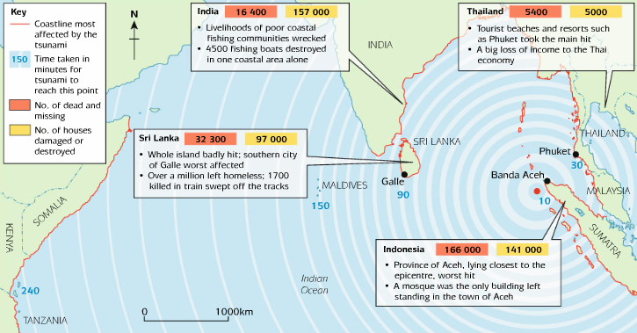
Background: In open ocean the tsunami measured less than 1 metre high. The tsunami travelled at speeds up to 800km per hour. When the Tsunami reached the shores, the height of the wave increased to 15 metres in some areas
Primary effects of the tsunami:

* 250,000 people died.

2 million people were made homeless.

People were swept away in the waters, which arrived rapidly and with little warning.

13 countries were affected, the worst being Indonesia - Indonesia was hit by the tsunami first. Fourty-five minutes later the tsunami reached Thailand

Mangrove swamps helped to act as a barrier to reduce the energy of the water in some areas
India’s Andaman and Nicobar Islands were also badly affected. At least 1894 of the islands’ 400,000 people were killed and more than 5500 are still listed as missing – 4500 from Katchall Island alone.
The force of the tsunami drove approximately 100,000 tonnes of water onto every 1.5m of coastline and therefore caused considerable erosion in some parts and devastating deposition in others.
Coral reefs and beds of sea grass which form the basis of many marine ecosystems have been damaged, and large swathes of mangrove have been uprooted.
On the east coast of Sri Lanka sea turtles were affected - almost all of the hatcheries were destroyed when the sandy beaches were washed away. On a single beach approximately only 400 out of the 20,000 turtle hatchlings survived.
Secondary effects the tsunami:
Salt water contaminated many sources of fresh water and destroyed large areas of arable land.
Thailand has not asked for disaster relief aid, but it has requested technical help to take DNA samples from the bodies to identify the dead. This took over a year to complete.
The destruction of the sea defences, such as mangrove, and the increasing human impact on the coastal zone, such as shrimp and fish farms, beach development, overfishing, and climate change, mean that the chances for beaches and ecosystems to recover are very limited. The recovery will be a very long and slow process.
Rescue services and emergency teams were not prepared for the scale of the disaster. Injured people were untreated for days, causing wounds to turn gangrenous. Cholera, diarrhoea and other diseases became widespread as bodies littered the street before being buried in mass graves by troops using bulldozers.
Short term responses to the tsunami: | Longer term responses to the tsunami:
Short-term aid, such as water purification tablets, temporary housing and medical supplies were given from international countries.  Many people posted photos in affected areas in the hope that a loved one had survived.  There was an immediate and unprecedented response from the international community; fresh water, water purification tablets, food, sheeting and tents all poured in as aid.  Medical teams and forensic scientists arrived.  Cargo planes and trucks from all over the world brought blankets, medicines and body bags.  Air drops to cut-off coastal communities provided relief to people stranded among the debris.  The UK government promised £75 million and public donations of £100 million followed; over £450 million had been pledged worldwide within one week. | Islands reliant on tourism and fishing, such as the Maldives, had to rebuild their industries.  An early warning system between countries surrounding the Indian Ocean has been set up.  A year later, £372 million had been donated by the British public, but only £128 million had been spent by the Disasters Emergency Committee (DEC). There were organisational problems following the collection of such large sums of money. However, rebuilding was progressing and the DEC had spent £40 million on projects in Sri Lanka and Indonesia with plans to spend a further £190 million in the second year, building 20 000 houses for 100 000 homeless people. Tourism, especially in Thailand continues to be badly affected, hampering the economic recovery of the area. The estimated cost of the reconstruction stands at £2.5 billion.

Prediction and Prevention
Prior to the tsunami there had been no early-warning system in the Indian Ocean. Ironically, proposals to introduce one had been rejected the previous year as the cost was judged to be excessive. The Indian Ocean Tsunami Warning System was set up in June 2006 using satellites and a network of floating buoys to identify underwater earthquakes and ensuing signs of a tsunami. Ensuring people know how to respond and that local authorities have plans in place are essential for its success. Soon after an earthquake off Indonesia measuring 8.4 on the Richter Scale in September 2007, authorities in Kenya evacuated people from the coastal resort of Mombasa and warned local fishermen not to go out to sea following a tsunami alert.
- Use a case study to describe the responses to a tsunami. (8 marks)

- Use a case study to describe the effects of a tsunami. (8 marks)

