Subject: A Level PE
Task 1: Anatomy and physiology.
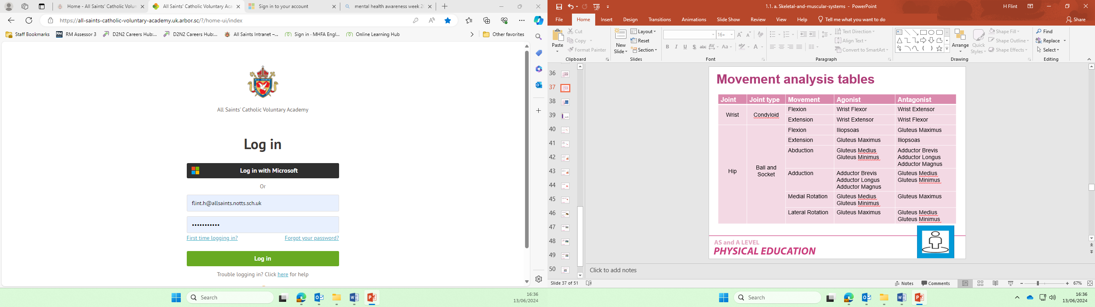
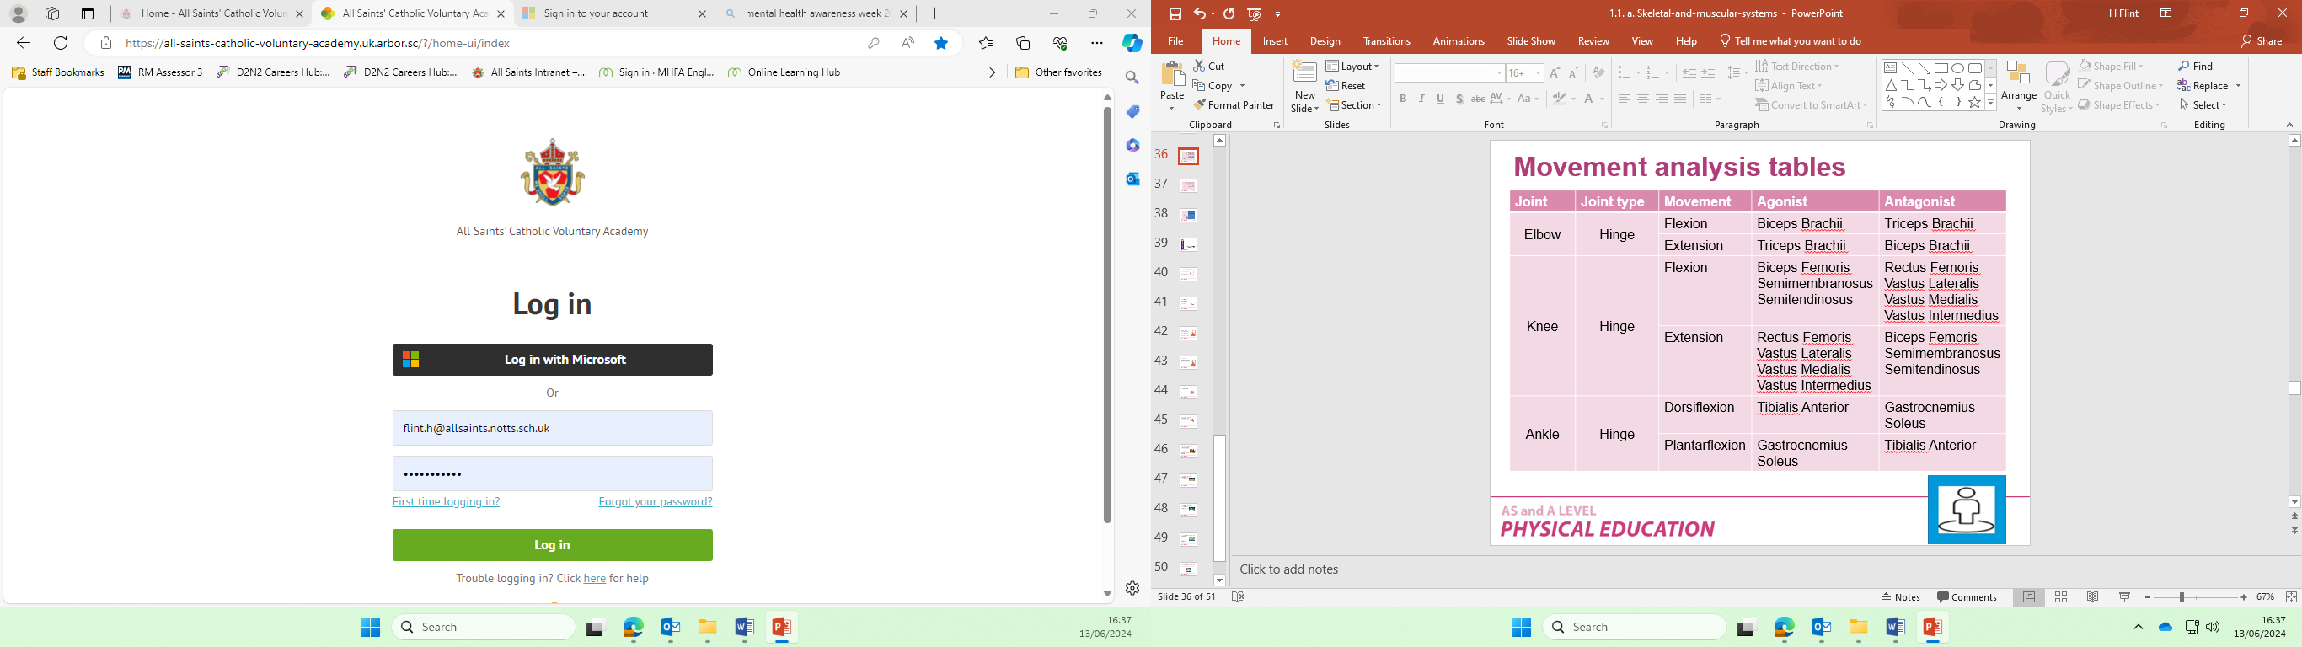
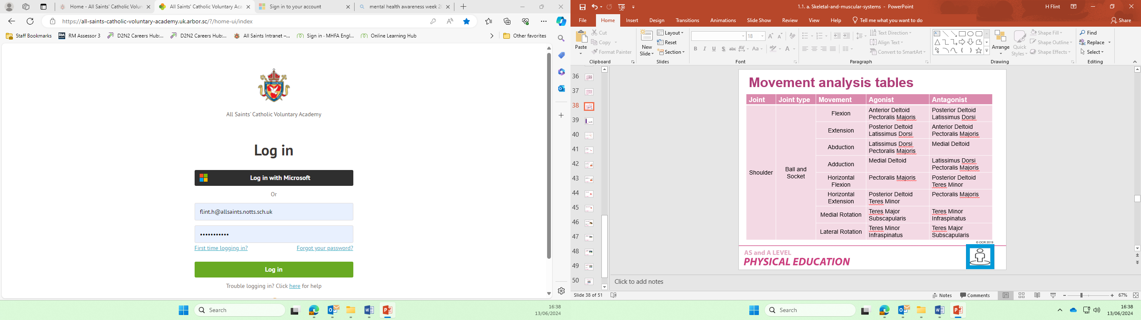
Using a skill specific practical example of your choice:
1.Annotate a diagram of a sports performer in the preparation and execution phase, with the agonist and antagonist muscles (using the grid above) for 3 different joints.
2.Write a summary to explain: The role of an agonist, antagonist and fixator muscles (definition of what they are)
For each joint how the muscles are helping the performer to execute the skill within the diagram chosen.

Example diagram to show preparation and execution phase (not to use):

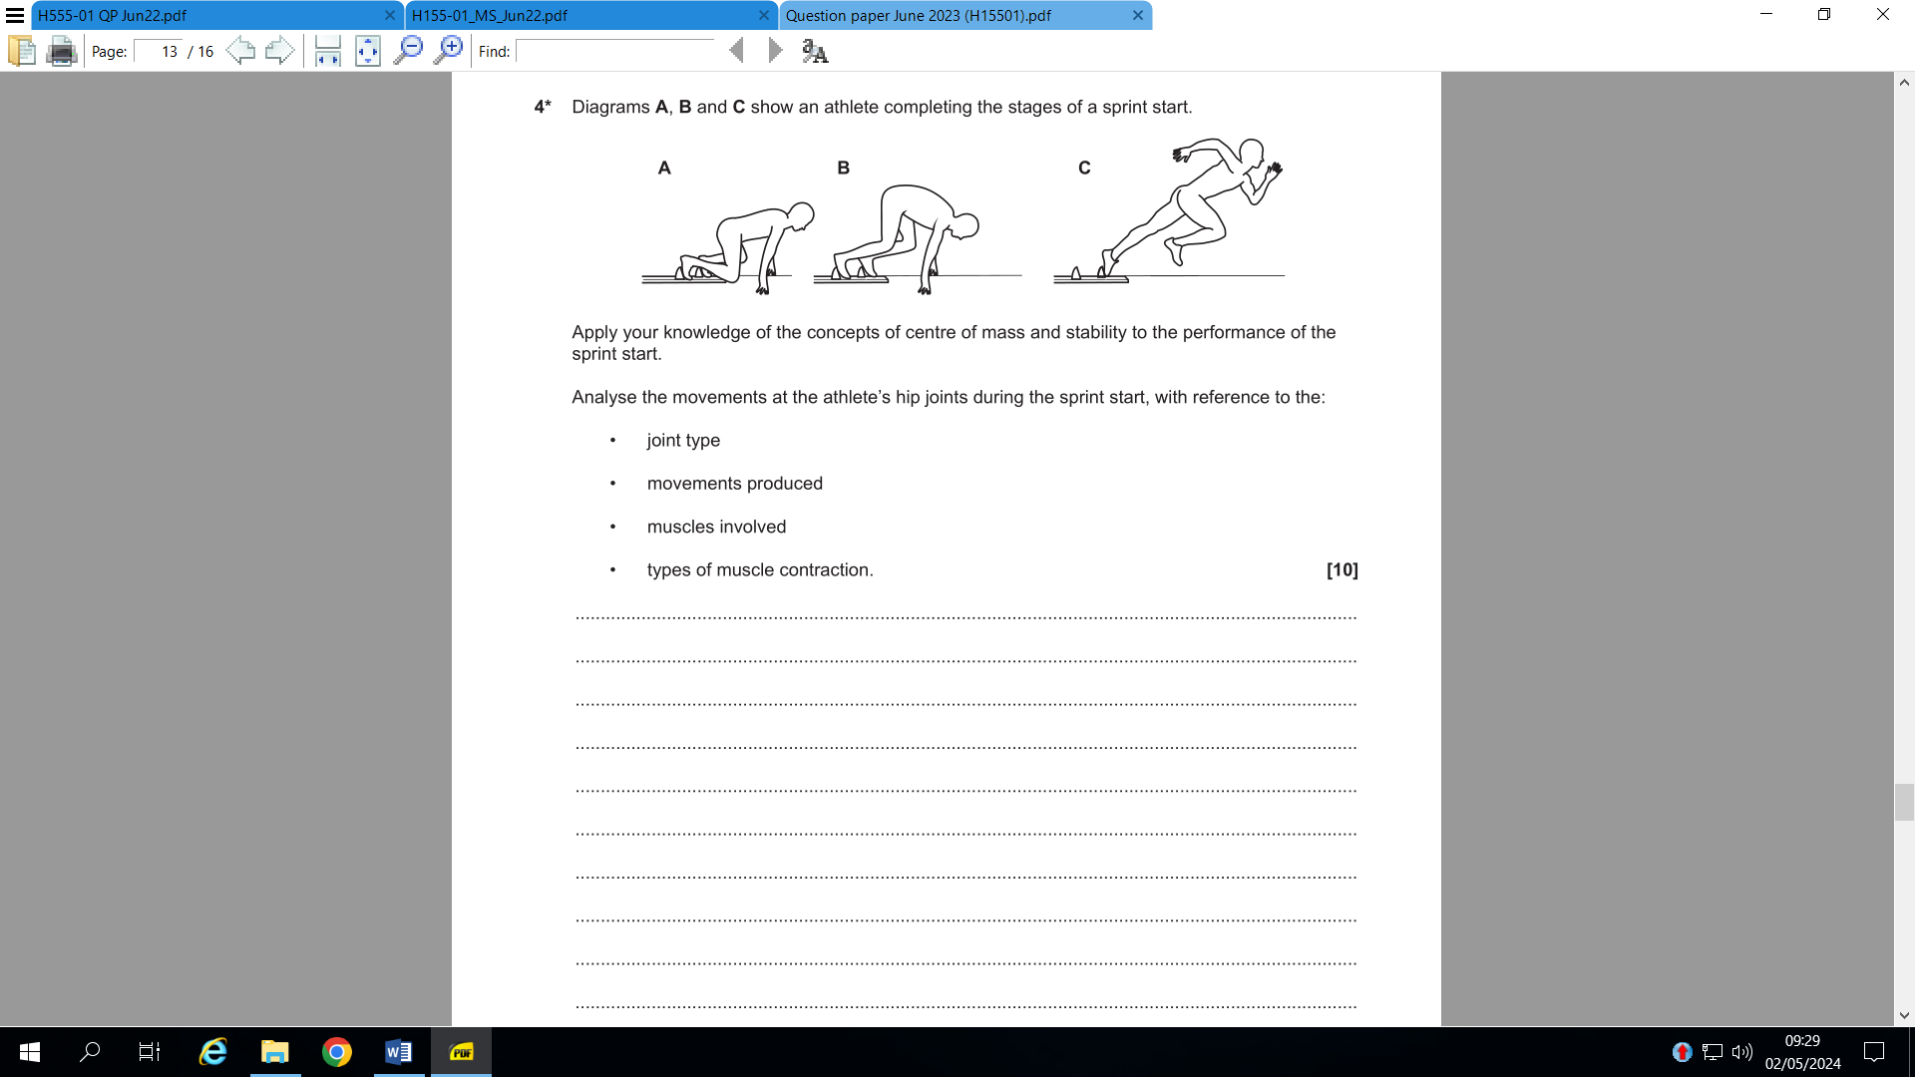
Preparation phase (A) Execution phase (C)

If you cannot remember the joint actions go to: A level PE Joint Movements 2020 (youtube.com)
Task 2: Psychological Factors Affecting Performance. Classification of Skills: Using the interactive resources produce an absolute describing the following classification of skills applying at least 6 practical examples.
- Difficulty (simple-complex)
- Environmental influence (open-closed)
- Pacing (self-paced-externally paced)
- Muscular involvement (gross-fine)
- Continuity (discrete-serial-continuous)
- Organisation (low - high).
Task 3: Socio-Cultural Issues in Sport. Research how social and cultural factors shaped the characteristics of, and participation in, sports and pastimes in pre-industrial Britain: Produce a detailed time line explaining the developments from 1850- 1900. Provide practical examples throughout.
- social class
- gender
- law and order
- education/literacy
- availability of time
- availability of money
- type and availability of transport.
Why is this required for September?
In completing all three tasks this will provide a foundation of knowledge, that will support all components that will be assessed in your Mock Exams, term one.
What Assessment/Feedback should you expect?
You will complete a retrieval task in three separate lessons. Please ensure you bring your bridging task to lessons the first week back.
Time this task (s) should take:
Minimum of 2 hours.
Suggested links or other resources to support:
OCR A Level PE - Skill Classification (youtube.com) https://www.youtube.com/watch?v=z7psWfRLXFY
Optional Extra tasks:
Consider watching the following to gain a deeper understanding of sport: Beckham, Schumacher, Formula 1, The last Dance, Captains of the world, Athlete A, Under Pressure, Untold, Icarus, Breaking Point, Hillsborough, Lance, Price of Gold, Olympic Dreams of Russian Gold-Over the Limit.
How will this link to independent study tasks in September?
In September you will complete a range of independent study tasks that will require you to research, explore and consolidate your knowledge.

