**Sociology Entry Task**

**Support Booklet**

This workbook is to help you structure your research and answer to the following essay question.

**Item**

Marxists see society as based on conflict between social classes. Those who own the means of production are able to exploit those who do not and are also able to impose their views on society. However, different Marxists have different views about the nature of capitalist society and about how social change occurs

Applying material from the item and your knowledge, evaluate the usefulness of Marxist approaches in understanding Society.

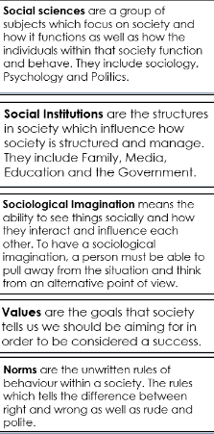

**Marxism**

Websites

[https://revisesociology.com/2016/04/10/the-marxist-perspective-on-society/ty – ReviseSociology](https://revisesociology.com/2016/04/10/the-marxist-perspective-on-society/ty%20–%20ReviseSociology)



<https://www.tutor2u.net/sociology/topics/marxism>



Videos

<https://www.youtube.com/watch?v=BC6WYXhY0co>

<https://www.youtube.com/watch?v=zZj-aaH7joc>



What are the features of a capitalist society?

What are the features of a communist society?

Identify the two terms identified by Karl Marx for the different classes, explain how the ruling class maintain their power in society

What is alienation?

What is false consciousness

Provide two criticisms of Marxism

**Functionalism**

**Websites**

[**https://revisesociology.com/2016/01/23/functionalist-theory-sociology/**](https://revisesociology.com/2016/01/23/functionalist-theory-sociology/)

[**https://www.cliffsnotes.com/cliffsnotes/subjects/sciences/what-is-the-functionalist-perspective-in-sociology**](https://www.cliffsnotes.com/cliffsnotes/subjects/sciences/what-is-the-functionalist-perspective-in-sociology)

**Videos**

[**https://www.youtube.com/watch?v=wFgot8TJtmo**](https://www.youtube.com/watch?v=wFgot8TJtmo)

[**https://www.youtube.com/watch?v=TryzRwyWfdI**](https://www.youtube.com/watch?v=TryzRwyWfdI)

What is meant by a consensus structural approach?

How does society shape the individual according to Durkheim?

What are the ways that society maintains the value consensus and social order?

Identify what is meant by GAIL and explain each term

To what extent is the Functionalist view of society too positive to be considered useful?

**Feminism**



**Websites**

<https://revisesociology.com/2017/02/03/feminist-theory-summary-sociology/>



<https://www.tutor2u.net/sociology/topics/feminism-1>

**Videos**

[**https://www.youtube.com/watch?v=D6Dl-9pSW-4**](https://www.youtube.com/watch?v=D6Dl-9pSW-4)

[**https://www.youtube.com/watch?v=aXHDvmb7n6c**](https://www.youtube.com/watch?v=aXHDvmb7n6c)

Identify the types of Feminism and explain their core ideas and how they differ

What do feminists mean by the following terms:

* Patriarchy
* Malestream Sociology

Now that you have completed the research for your essay you need to write your answer to the following question.

Applying material from the item and your knowledge, evaluate the usefulness of Marxist approaches in understanding Society.

See front of booklet for the item A

Remember to use connectives within your written work.

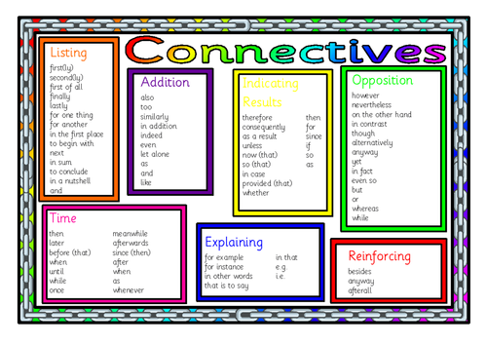

Essay Structure

Your essay should include the following in this suggested order:

1. Introduce the core sociological arguments – what are they and how are they different.
2. Description of each Sociological theory – what is the overall theory, ensure key concepts and theorists are used. Theories in support of the concept of subcultures with explanations of supporting research. Extend this further and discuss whether the theories are accurate and if there are any criticisms of them.
   1. Marxism
   2. Functionalism
   3. Feminism
3. Finally, you should finish with a clear conclusion summarising the arguments made and your own view point as what theory do you agree with i.e. is Marxism a useful theory to understanding society.