Subject: Psychology
Task:
You need to complete the tutor2u transition course. ‘Transition to A level psychology’ https://ondemand.tutor2u.net/students/transition-to-aqa-alevel-psychology-skills-booster?fbclid=IwZXh0bgNhZW0CMTEAAR014XDEDG-B2iov4XEj_SrlxthFTS_cy0jmYTR_dNpZCl4Kpx3qBrC5fw8_aem_AdlUJ20sfjvUJLXIo11V8B7nJKTPJFDn2hfcJjgynIcoH73Qzrw0XGEby5gQ0gkzfaJXfvGqsuq79_lZXexkdPwo

You need to make notes about the content and complete the worksheet which is provided with the course.

PLUS

You need to complete the mathematical skills GCSE to A level transition booklet. You then need to create suitable revision cards on the content covered.
Why is this required for September?
The induction course will provide key knowledge on theories in psychology which will be extended within the first few weeks of the course.
Psychology requires you to have a range of skills. It draws from your ability to write an essay, collect data and then analyse the data.
This booklet will help to identify any weak points in your foundational mathematical knowledge before you start your A Level in September and start you thinking about how to apply the skills you have learned in GCSE maths to Psychology. 10% of the assessed skills at A level psychology are mathematical so it is vital that you know how to apply concepts.
What Assessment/Feedback should you expect?
You need to provide evidence of the notes you have completed to your class teacher.

It is expected that you will self-assess the mathematical skills booklet and this will be checked by the class teacher. You must self assess using a green pen and the answer booklet.
The class teacher will require a photocopy of the ‘Review of learning’ (page 35) and check the standard of revision cards completed. Whole class feedback will be provided on revision strategies and any problematic areas.

This knowledge will be tested within the first half term and feedback provided.
Time this task (s) should take:
Minimum of 6 hours.
Suggested links or other resources to support:
Links in the document will support with any areas which are problematic.
Optional Extra tasks:
Register on the open university and complete one of the free open learn courses and don’t forget to print off your certificate of completion!
Starting with psychology | OpenLearn - Open University

Psychological research, obedience and ethics | OpenLearn - Open University

Investigating a murder with forensic psychology: Week 1: Introduction | OpenLearn - Open University (https://www.open.edu/openlearn/mod/oucontent/view.php?id=142136

Forensic psychology | OpenLearn - Open University

Understanding mental capacity | OpenLearn - Open University

The role of diagnosis in counselling and psychotherapy | OpenLearn - Open University

Prepare a folder (A4 lever arch) and print a copy of the specification (https://www.aqa.org.uk/subjects/psychology/as-and-a-level/psychology-7181-7182/subject-content-a-level) to go in the front.
You will need the following in your folder to support a smooth start to Y12:
- Dividers
- Plastic wallets
- Blank revision cards
You may also find punched plastic wallet pockets useful for storing revision cards (see image)
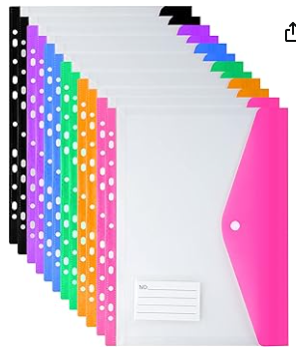
How will this link to independent study tasks in September?
Psychology requires you to have a foundation knowledge of both mathematics and science. You will be expected in independent study to create revision cards on key concepts and create essay plans for a range of topic areas. There is a large volume of information required so you need to establish good study habits from the start.

