**Preparing for A Level Maths September 2024**

**Welcome to A Level Maths**

A-Level mathematics is a very rich and rewarding course, that is extremely well valued by both employers and universities. It is, however, a challenging course. We want you to be ready to face these challenges and to do so you must be fluent in the number and algebraic skills that you studied at GCSE.

The purpose of this booklet is to inform you of the required skills for the A-Level mathematics course and the resources available to you to help you prepare.

**Useful equipment**

Just like in GCSE, there are a few optional and compulsory pieces of equipment that will aid you through the Maths course. You will be in an advantageous position if you have these ready for September:

* Usual equipment such as pens, pencil, ruler, rubber, highlighter etc. (compulsory)
* Whiteboard pens. (compulsory)
* A4 lined/file paper. (compulsory)
* Folder (either a standard one or an arch-lever folder), with dividers. (compulsory)
* A-level calculator (CASIO fx-991EX or CASIO fx-991CW). (compulsory)
* Textbook(s) if you’d like to purchase your own. (optional)
  + Year 12: ISBN-13: 978-1316644287, “A-Level Mathematics for OCR Student Book (AS/Year 1)”. Red cover
  + Year 13: ISBN-13: 978-1316644300, “A-Level Mathematics for OCR Student Book (A2/Year 2)”. Green cover

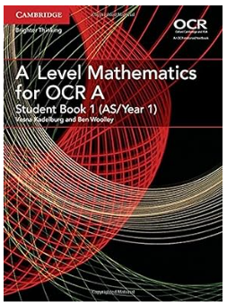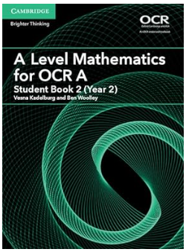

* Geometry set. (optional)
* Mini-whiteboard + rubber/cloth. (optional)
* Digital writing tablet to aid in private study on computers. (optional)
* Plastic wallets for your folder. (optional)
* Labels for organising the various topics that you will learn. (optional)

**Summer Task**

To support you in your preparation for A Level Maths, we have compiled a selection of questions that we would like you to complete. These will help you prepare for beginning the course in September and for your baseline test. You can use the resources below to help you.

**GCSE to A Level Maths Bridging the Gap**

[TLMaths - GCSE to A-Level Maths Bridging the Gap](https://www.tlmaths.com/home/gcse-to-a-level-maths-bridging-the-gap)

https://www.tlmaths.com/home/gcse-to-a-level-maths-bridging-the-gap

This website has a selection of videos that talk through the basics of GCSE Maths Higher tier ready for starting the course.

**Other useful websites**

* Corbett Maths ([www.corbettmaths.com](http://www.corbettmaths.com))
* Dr Frost Maths ([www.drfrost.org](http://www.drfrost.org), login required)
* Maths Genie ([www.mathsgenie.co.uk](http://www.mathsgenie.co.uk))

**Further reading/thinking outside of the box**

[Transition to A level Mathematics: Essential Skills - AMSP](https://amsp.org.uk/teachers/11-16-maths/transition-to-level-3-maths/essential-skills/)

https://amsp.org.uk/teachers/11-16-maths/transition-to-level-3-maths/essential-skills/

The questions in this booklet are from the “Transition to A Level Mathematics: Essential Skills” website provided by AMSP (Advanced Mathematics Support Programme). These include further practice and have extra ideas that you may want to investigate further.

**Revision Guides**

If you would prefer a revision guide – CGP have a “Head Start to A-Level Maths” revision guide.

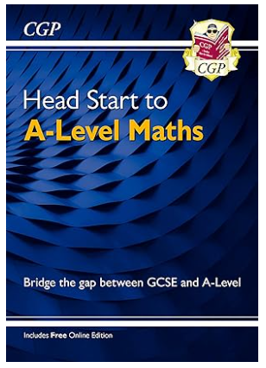

If you have any questions, please contact Mr Wan at [Wan.S@allsaints.notts.sch.uk](mailto:Wan.S@allsaints.notts.sch.uk).

**1a - Fractions**

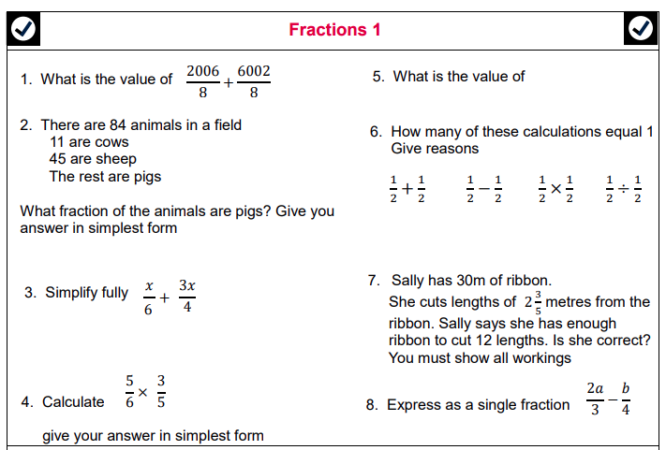

**1b - Indices**

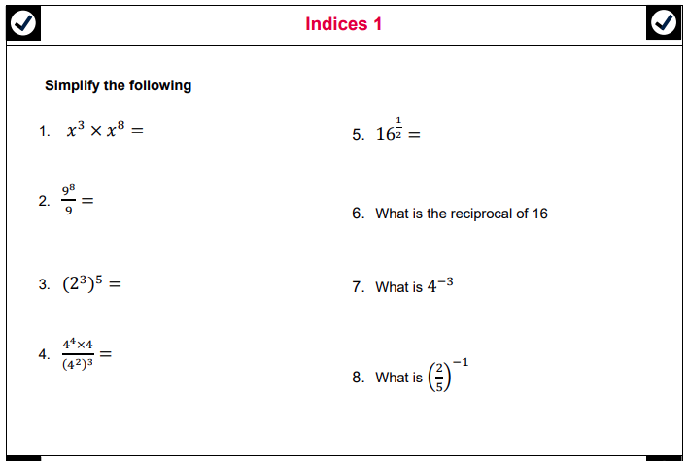

**1c - Indices**

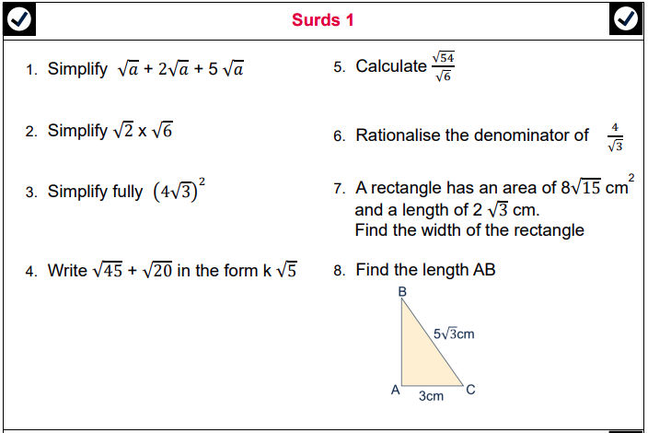

**2a – Expanding brackets**

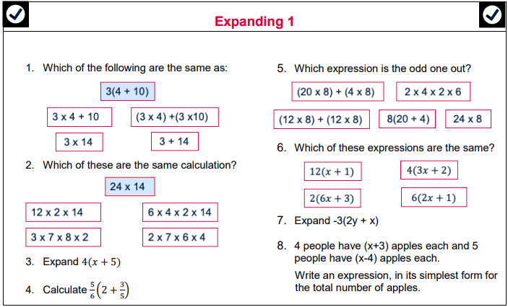

**2b – Expanding brackets**

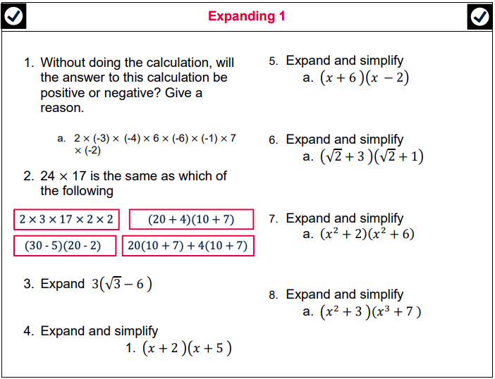

**2c – Expanding brackets**

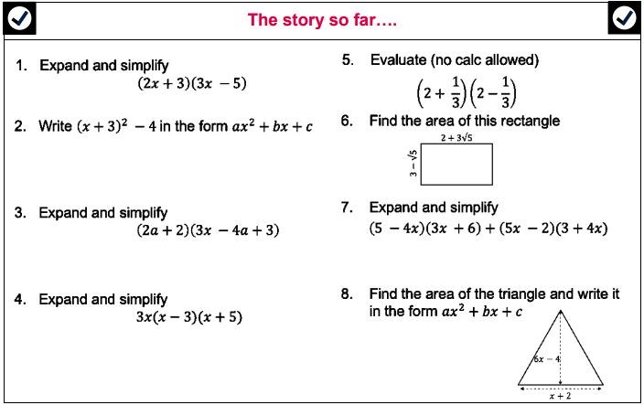

**3a – Factorising**

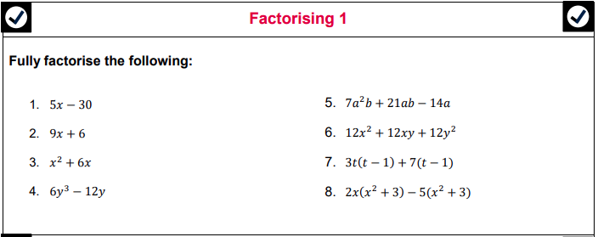

**3b – Further Factorising**

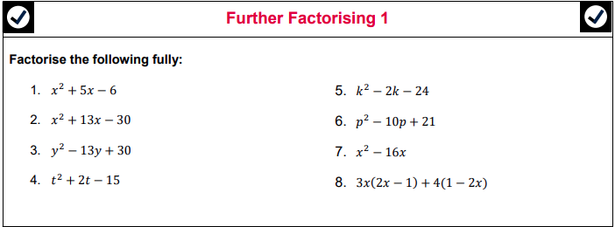

**3c – Completing the square**

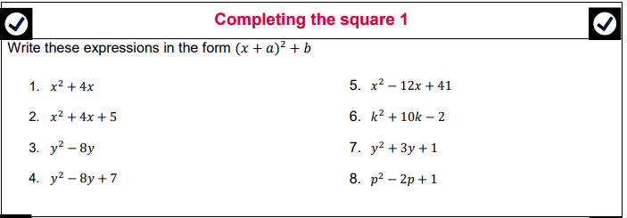

**4a – Rearranging 1**

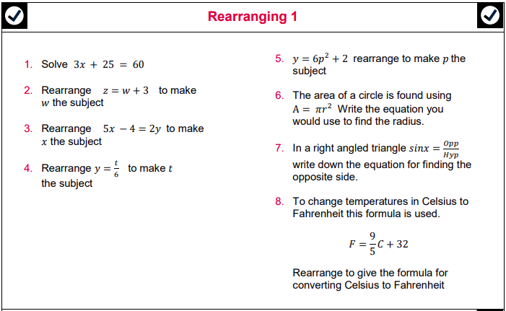

**4b – Rearranging with factorising**

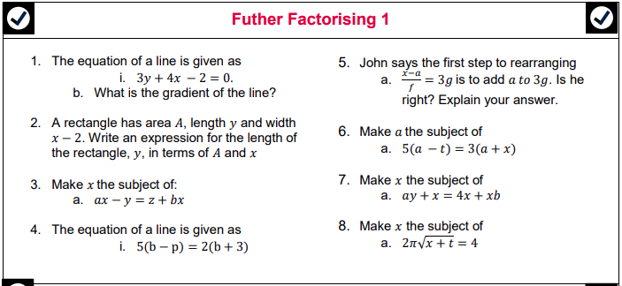

**4c – Rearranging with fractions**

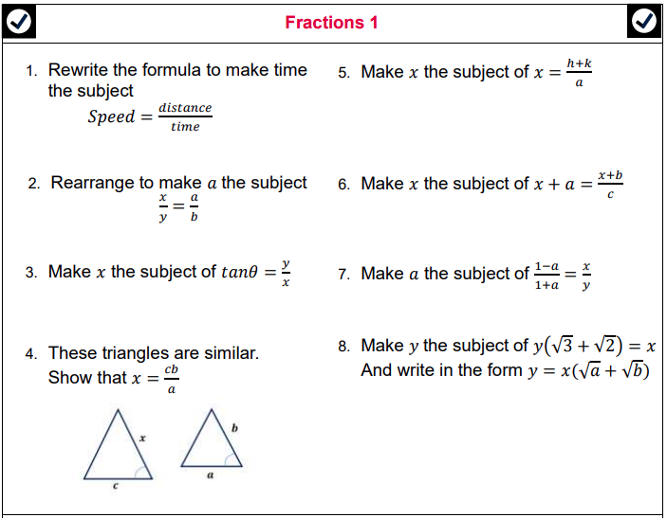

**5a – Solving linear equations/inequalities**

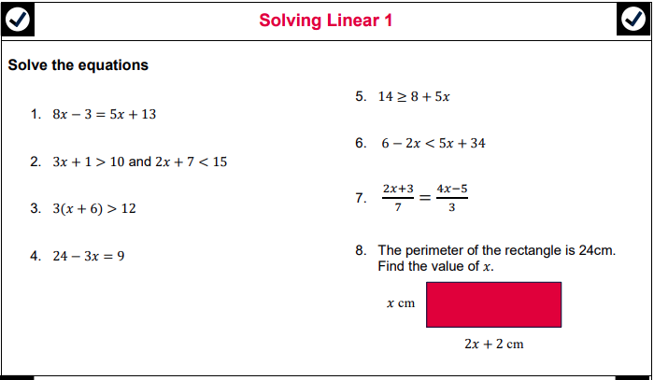

**5b – Solving quadratic equations**

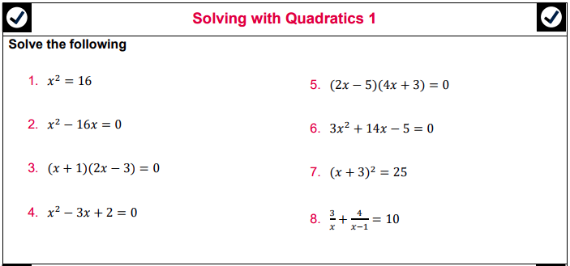

**5c – Solving equations with trigonometry**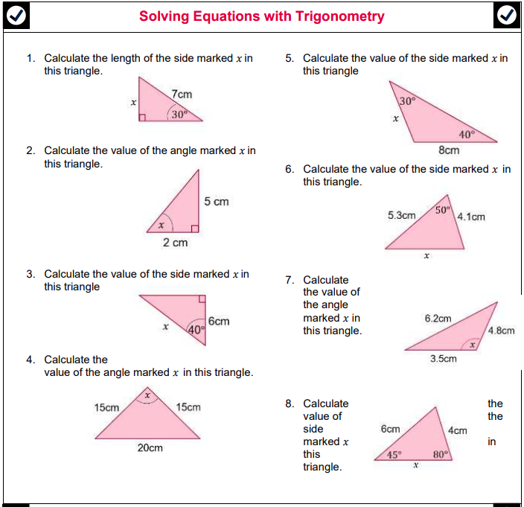

**6a – Linear graphs**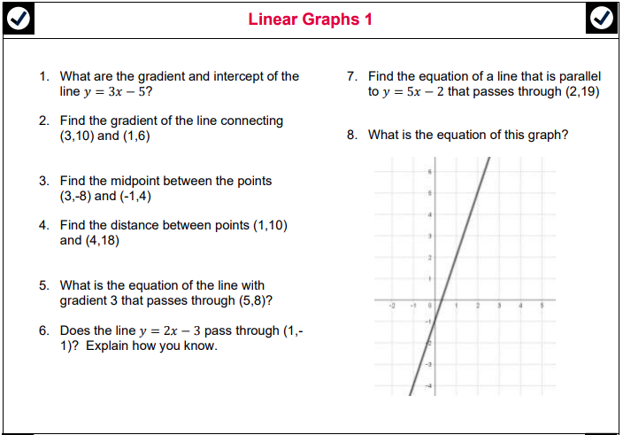

**6b – Quadratic graphs**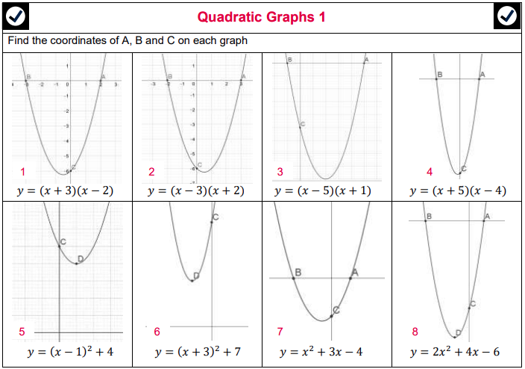

**6c – Sketching other graphs 1**

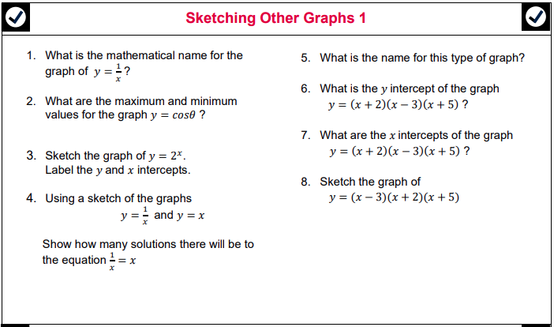

**Part 1 – Simplifying solutions**

**1a - Fractions 1**

|  |  |  |  |
| --- | --- | --- | --- |
| **1** |  | **5** |  |
| **2** |  | **6** |  |
| **3** |  | **7** |  |
| **4** |  | **8** |  |

**1b - Indices 1**

|  |  |  |  |
| --- | --- | --- | --- |
| **1** |  | **5** |  |
| **2** |  | **6** |  |
| **3** |  | **7** |  |
| **4** |  | **8** |  |

**1c - Surds 1**

|  |  |  |  |
| --- | --- | --- | --- |
| **1** |  | **5** |  |
| **2** |  | **6** |  |
| **3** |  | **7** |  |
| **4** |  | **8** |  |

**Part 2 – Expanding solutions**

**2a - Expanding 1**

|  |  |  |  |
| --- | --- | --- | --- |
| **1** |  | **5** |  |
| **2** |  | **6** |  |
| **3** |  | **7** |  |
| **4** |  | **8** |  |

**2b – Expanding brackets**

|  |  |  |  |
| --- | --- | --- | --- |
| **1** |  | **5** |  |
| **2** |  | **6** |  |
| **3** |  | **7** |  |
| **4** |  | **8** |  |

**2c – The story so far**

|  |  |  |  |
| --- | --- | --- | --- |
| **1** |  | **5** |  |
| **2** |  | **6** |  |
| **3** |  | **7** |  |
| **4** |  | **8** |  |

**Part 3 – Factorising solutions**

**3a - Factorising 1**

|  |  |  |  |
| --- | --- | --- | --- |
| **1** |  | **5** |  |
| **2** |  | **6** |  |
| **3** |  | **7** |  |
| **4** |  | **8** |  |

**3b – Further factorising**

|  |  |  |  |
| --- | --- | --- | --- |
| **1** |  | **5** |  |
| **2** |  | **6** |  |
| **3** |  | **7** |  |
| **4** |  | **8** |  |

**3c - Completing the square**

|  |  |  |  |
| --- | --- | --- | --- |
| **1** |  | **5** |  |
| **2** |  | **6** |  |
| **3** |  | **7** |  |
| **4** |  | **8** |  |

**Part 4 – Rearranging solutions**

**4a – Rearranging 1**

|  |  |  |  |
| --- | --- | --- | --- |
| **1** |  | **5** |  |
| **2** |  | **6** |  |
| **3** |  | **7** |  |
| **4** |  | **8** |  |

**4b – Rearranging with factorising**

|  |  |  |  |
| --- | --- | --- | --- |
| **1** |  | **5** |  |
| **2** |  | **6** |  |
| **3** |  | **7** |  |
| **4** |  | **8** |  |

**4c – Rearranging with fractions**

|  |  |  |  |
| --- | --- | --- | --- |
| **1** |  | **5** |  |
| **2** |  | **6** |  |
| **3** |  | **7** |  |
| **4** |  | **8** |  |

**Part 5 – Solving solutions**

**5a – Solving linear equations/inequalities**

|  |  |  |  |
| --- | --- | --- | --- |
| **1** |  | **5** |  |
| **2** |  | **6** |  |
| **3** |  | **7** |  |
| **4** |  | **8** |  |

**5b – Solving quadratic equations**

|  |  |  |  |
| --- | --- | --- | --- |
| **1** |  | **5** |  |
| **2** |  | **6** |  |
| **3** |  | **7** |  |
| **4** |  | **8** |  |

**5c – Solving equations with trigonometry**

|  |  |  |  |
| --- | --- | --- | --- |
| **1** |  | **5** |  |
| **2** |  | **6** |  |
| **3** |  | **7** |  |
| **4** |  | **8** |  |

**Part 6 – Sketching solutions**

**6a – Linear graphs**

|  |  |  |  |
| --- | --- | --- | --- |
| **1** |  | **5** |  |
| **2** |  | **6** |  |
| **3** |  | **7** |  |
| **4** |  | **8** |  |

**6b – Quadratic graphs**

|  |  |  |  |
| --- | --- | --- | --- |
| **1** |  | **5** |  |
| **2** |  | **6** |  |
| **3** |  | **7** |  |
| **4** |  | **8** |  |

**6c - Sketching other graphs**

|  |  |  |  |
| --- | --- | --- | --- |
| **1** |  | **5** |  |
| **2** |  | **6** |  |
| **3** |  | **7** |  |
| **4** |  | **8** |  |