Subject: BTEC Level 3 Sport
TASK
Read the following scenario and use the information in the life style questionnaire to interpret the lifestyle factors and screening information for the client. Present this information in a written report or PowerPoint presentation.
“David Smith is 30 years old and works a 40-hour week in an office administration role. He has not undertaken any exercise for at least ﬁve years. He takes the train to work each day, a journey that last approximately 15 minutes. While on holiday recently, he noticed he had gained weight (10 kg in the last two years). His best friend has suggested that he starts playing football with him and his friends again, but David is worried he will not be able to play like he once could and will suffer on account of his increased weight and obvious lack of ﬁtness. David has decided to join a local gym and undergo a full ﬁtness assessment, so that in the weeks ahead, he may be able to start playing ﬁve-a-side football again. He has completed a PAR-Q form and indicated that he has no medical conditions and is ﬁ t to take part in physical activity. Consequently, David has been given a 6-week training programme to follow”.
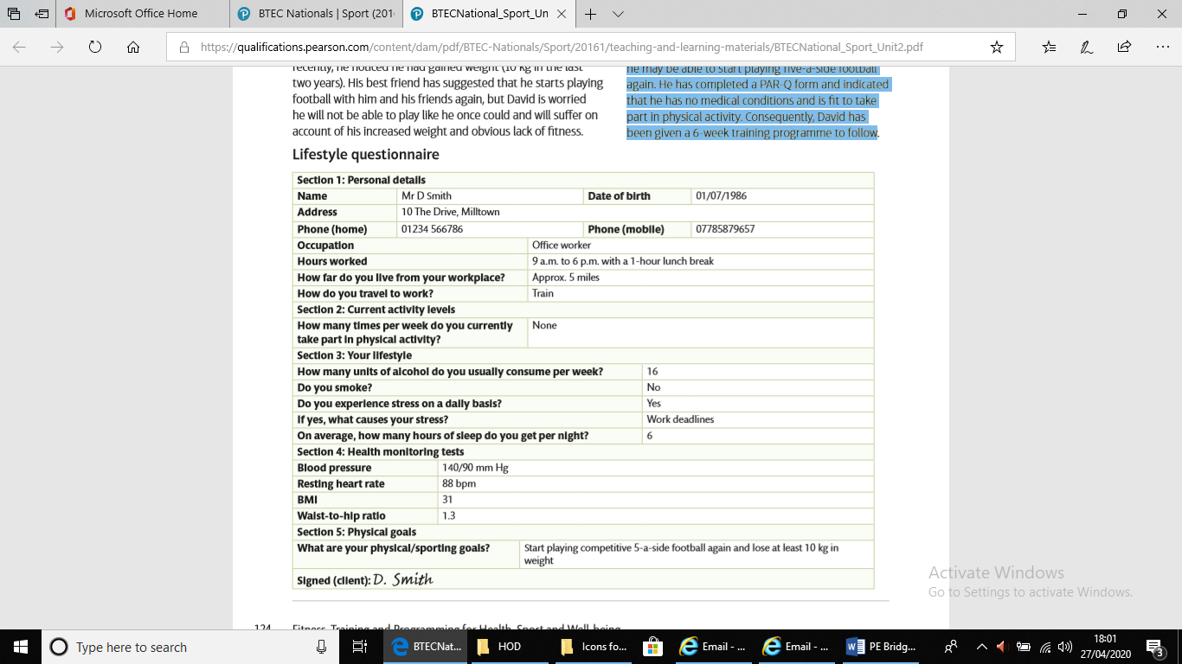
Example: David is 30 years old and his BMI suggests he is overweight and needs to lose between 8 and 10 kg. His blood pressure is too high and he should drink less alcohol. He has an oﬃce job and does not get any exercise during the day or at home. Says he wants to play football again but afraid he will make a fool of himself because he is too fat and not ﬁ t enough. Wants to change his lifestyle.

Task 2: Design a 6-week training programme for David to follow, which will aim to improve his overall fitness. Demonstrate progression, overload gradually throughout the programme.
Task 3: Discuss the barriers to David’s fitness and Exercise plan. Explain how he could overcome these barriers. Barriers to discuss are time, cost, transport and location.

Why is this required for September?
In completing both tasks this will provide a foundation of knowledge that will help you apply your knowledge and Understanding.
What Assessment/Feedback should you expect?
You will complete a retrieval task in three separate lessons. Please ensure you bring your bridging task to your first lesson.
Time this task (s) should take:
Minimum of 2 hours.
Suggested links or other resources to support:
https://www.youtube.com/watch?v=DcTTOsptCMk
Book: Revise BTEC National Sport Units 1 and 2 Revision Guide
Optional Extra tasks:
Consider watching the following to gain a deeper understanding of sport: Beckham, Schumacher, Formula 1, The last Dance, Captains of the world, Athlete A, Under Pressure, Untold, Icarus, Breaking Point, Hillsborough, Lance, Price of Gold, Olympic Dreams of Russian Gold-Over the Limit.
Gain further Practical experience by joining a Local Club.
How will this link to independent study tasks in September?
In September you will complete a range of independent study tasks that will require you to research, explore and consolidate your knowledge.

